**BANK MANAGEMENT SYSTEM**

UNDER THE GUIDANCE OF

Miss:- Jagruti Yashwant Pawar

Submitted to:- W.K.B.SEVA MANDAL DHULE’S

Dr.S.R. Ajmera B.C.A College

(Affiliated to SNDT Women’s University ,Mumbai)

Submitted By:- Miss.Vibhavi Khairnar

ACKNOWLEDGEMENT

We are extremely grateful and remain indebted to our guide Miss.  Jagruti y. pawar for being a source of inspiration and for her constant support in the Design, Implementation and Evaluation of the project. We are thankful to them for their constant constructive criticism and invaluable suggestions, which benefited us a lot while developing the project on “BANK MANAGEMENT SYSTEM”. she has been a constant source of inspiration and motivation for hard work. she has been very co-operative throughout this project work. Through this column, it would be our utmost pleasure to express our warm thanks to her for their encouragement, co-operation and consent without which we mightn’t be able to accomplish this project.

           We also express our gratitude to Miss jagruti y.pawar for providing us the infrastructure to carry out the project and to all staff members who were directly and indirectly instrument in enabling us to stay committed for the project.

**INDEX**

|  |  |  |
| --- | --- | --- |
| Sr. no | Index | Page no |
| 1 | Process Description |  |
| 2 | Introduction |  |
| 3 | Project Details |  |
| 4 | Front End (VB.net C#) |  |
| 5 | Back End (MS-Access) |  |
| 6 | Hardware and Software Specification |  |
| 7 | Table Dictionary |  |
| 8 | Table Design |  |
| 9 | Forms Design |  |
|  |

**INTRODUCTION**

The main objective of the project is to develop online/offline Banking system for banks. In present system all banking work is done manually. User have to visit bank to Withdrawal or Deposit amount. In present bank system it is also difficult to find account information of account holder. In this bank management system we will automate all the banking process. In our bank management system user can also transfer money to other account online. In this Software you can keep record for daily Banking transactions. The main purpose of developing bank management system is to design an application, which could store bank data and provide an interface for retrieving customer related details with 100% accuracy.

This bank management system also allow user to add new customer account, delete account and user can also modify existing user account information. Using this system user can also search any individual account in few seconds. Using our bank management system user can also check any translation in any account. Our system also provide security check to reduce fraud. The system will check the user’s existence in the database and provide the set of services with respect to the role of the user.

The objective of this bank management system are:-

The main object of this system is to provide a secure system. Our system is password protected and it only allows authorized user to access various functions available in the system.

Our system will help the user to Locate any A/C wanted by the user. It will Reduced manual work as most of the work done by computer. As all the manual work will be done automatically so it will increase work speed and reduce time consumption to complete any bank related work. It will also increase the work efficiency as few employees can handle more customers. This will reduced the manual workload and give information instantly.

The Project Banking system has been made to automate the Banking system. Through this bank management system user can manage all bank account activity like deposit money, withdraw money, transfer money from one account to another account, online payment etc. Using this bank management system user can check his account detail online like balance in account, bank statement etc. The Administrator can check bank account with a login can work out with A/C holders of the bank can withdraw/ deposit cash / cheque /DD to/from their accounts. This system is also help bank user to create New account easily. The project makes a sincere effort to provide all the below-mentioned features to meet the requirements of the bank.

In this project we have automate the bank process like Account Opening, Daily Transactions, Loan Sanctions, Account Maintenance. In this bank management system use can also search record of a particular Account Holder.

Using this system user can manage following account type

Savings Account

Current Account

Fixed Deposit Account

Recurring Deposit Account

Loan Account

FEATURES PROPOSED IN THE CURRENT BANK MANAGEMENT SYSTEM

The main objective of the system is to automate all the banking process with improved performance an realize the vision of paperless banking. Salient features of the proposed bank management system is given below.

Using this bank management system any information can be easily searched. User can view all the details of the customer.

Using this system user can create new customer account and maintain its data efficiently and effectively. All records of account and customer are stored in separate files. Which are maintained constantly update by system.

Manage large number of customer details with ease. Particular A/c information can be modified A particular customer record can be modified for one or more field’s customer name, address by providing A/c number.

Create a statistical report to facilitate the finance department work. Activities like updating, modification, deletion of records should be easier. A customer record can be easily deleted by authorize user by providing A/c number.

The proposed system provides faster data access, data entry and retrieval.

The proposed system is more efficient, fast, reliable, user friendly. Over and above the proposed system does not have any possibility of data loss during processing.

**VISUAL BASIC**

          **DATA TYPE SUMMARY**

Visual Basic recognize following six types of variables as Numeric, String, Boolean, Date, Object, Variant.

**NUMERIC**

           Like other Programming Language Visual Basic provide Numeric Variables. They are:- Integers, Single, double, Byte, Long, Currency

          Integer Variables are used for the Non Fractional Values. It stores values in the range from – 32768 to 32767. Long Data type is used for the range –2147483648 to 2147483647. Single Data Type is used for Fractional Values from –3.402 e 38 to 1.40 e 45. Double Precision Floating Point Numbers is capable of containing values from –1.797 e 308 to 4.940 e 324 and positive numbers. Currency is used for fixed-point numbers with four decimal digits. It can represent numbers in the range –922377203685477.5808 to 922377203685477.5807. Byte data type is used for representing numbers from 0 to 255. String variables are used to store string type data.

**BOOLEAN**

          Boolean Data Type stores True/ False values. Boolean variables are used in testing conditions.

**DATE**          Date and Time variables are stored internally in a special format, but you don’t need to know the exact format. Date variables are declared by following statements.

**OBJECT**

          An object variable is used to refer any object in the application they are declared by the object data type and after that they are set to any of the object in the applications with set command.

**VARIANT**

          Special Types of Variables declare without any data type treated as variant they are capable of containing any type of value. If one can skidata type in variable declaration statement then variable will treated as a variant

**About Front – End:**

**Features of .NET C#*:-***

**Terminology:-**

* **Forms:-**

The form is the central unit in .net C#. It is window, initially blank, on which you paste controls to create your screen or printer display. The form can be any size or color, and you can attach to it code that will run when the form is loaded, closed or when the mouse is clicked on moves over it. A simple program may use only one form; other may have several forms each of which will handle a different part of program. One form may be getting input from the user, a second for displaying results on the screen, a third for sending output to the printer. Each form is saving on disk as separate file with a form extension.

* **Controls :-**

These are the objects, which can be pasted onto a form and range from labels, which display text through picture boxes for graphic images, to buttons, check boxes, lists and other menus, to file management utilities and spreadsheets style grids. Their properties and the events they handle, vary to suit their nature. Each control can have code attached to it through not all will have. A text label or graphic images, for example, may well be there simply to improve the display and not as the start point for any activities

**About Back – End:**

**MICROSOFT ACCESS :-**

* **Designing A Database :-**

An important point to keep in mind as you can begin Creating a database is a good design. Without a good design you will be a constantly changing the database structure or you may not be able to extract the information you want from your database. To create a database you need to complete a series of steps known as design steps. The aim of this process is to be produce a compact and efficient data structure.

* **Management Database Structure:-**

It is important to understand the overall need of the system before you begin to work on the details. For instance, you must know the logical flow of activities in the system. If you need to known the process of purchase, cataloging, classification and issues only after you have understood the sequences of activities can you decide upon the data structure.

The ultimate purpose of every DBMS is the generation of reports and quires. Therefore, you need to remember the final output that your system is designed to generate and decide the data structure accordingly.

You need to design you database in such manner that data integrity is maintained at all levels. Data integrity refers to a state of the database where none of the data is duplicated or inconsistent,

After you have spit up your database into multiple tables, the next step is to set relations between them in such a manner that a query or report can retrieve the data from multiple tables. Access does these matching primary keys with the foreign keys in the other tables

After you have decided upon the tables that you will have in your database, you can define the various fields and their properties

For every field you should decide the:-

* 1. Field Name
  2. Field type.
  3. Field size.

One of the most important tasks is ensuring data integrity. For example, you can define data entry rules and data validations. This ensures that only valid and consistent. Data is stored in the table and inconsistent data is rejected. A database also consists of various objects like forms and reports that manipulate and display data. After you created the table, you need to design data entry and display forms, queries and reports. You will also need macros of automate routine tasks. These objects must be created keeping in mind the format of the object, you can either custom design it or create it with the help of the wizards.

After you have designed the database the table structure on paper, you can begin creating a database. There are several ways in which you can create a database. You can create a blank database and add tables and other objects yourself alternatively you can invoke the database creation wizard to create a database. Access has several database templates, such as inventory control; address book and music collection that the wizard can create for you. You can then modify these databases to suit your requirements.

**Steps to create a Database Are:-**

1. Invoke Access

2. Select the button in the “Create a new Database Using” block

It has following types:-

* 1. Blank Database
  2. Database Wizard
  3. Open Existing Database

**Opening a Database:-**

You can open database by suing an existing database radio button from the opening screen of access. A list of database that you have created is displayed. If the database is located on a network on a network or diskette, select the more files option. The slandered open screen is displayed

The exclusive checkbox determines whether other user will be able to share data from the databases while you have opened it. If you do not want other users to share the file click the check box

**Steps to create a Table:-**

1) Select the table tab in the databases window and click on the “New” Button. A new table’s dialogs box is displayed. Use this dialog box to select one of the five ways to create a new table

* Datasheet View.
* Design View.
* Table Wizard.
* Import table
* Link Table

**Hardware And Software Specification:-**

* **Hardware Requirements :-**
* Windows 10
* Monitor.
* Keyboard.
* CPU.
* Mouse.
* The driver of capacity 1.2MB.
* The memory should have capacity to store 40 files,
* 60 buffers.
* Any system driver whose version 3.0 can be used.
* **Software Requirements :-**
  + .NET( C#)
  + Ms Access.

1.LOGIN

|  |  |  |
| --- | --- | --- |
| Sr no | Field | Type |
| 1. | - | Panel |
| 2. | - | PictureBox |
| 3. | - | PictureBox |
| 4. | welcome to | Label |
| 5. | BANK | Label |
| 6. | MANAGEMENT | Label |
| 7. | SYSTEM | Label |
| 8. | Login Id | Label/Textbox |
| 9. | Password | Label/Textbox |
| 10. | Login | Button |
| 11. | Cancel | Button |

2.HOME

|  |  |  |
| --- | --- | --- |
| Sr no | Field | Type |
| 1. | - | Panel |
| 2. | BANK MANAGEMENT SYSTEM | Label |
| 3. | - | PictureBox |
| 4. | - | panel |
| 5. | MENU | Label |
| 6. | - | PictureBox |
| 7. | Setting | Label |
| 8. | About Us | Label |
| 9. | Feedback | Label |
| 10. | Logout | Label |
| 11. | - | PictureBox |
| 12. | - | PictureBox |
| 13. | - | PictureBox |
| 14. | - | PictureBox |
| 15. | - | Panel |
| 16. | New Account | Button |
| 17. | Deposit | Button |
| 18. | Withdraw | Button |
| 19. | Transfer | Button |
| 20. | Account Details | Button |
| 21. | Department | Button |
| 22. | - | PictureBox |

3.REGISTRATION FORM

|  |  |  |
| --- | --- | --- |
| Sr no | Field | Type |
| 1. | REGISTRATION FORM | Label |
| 2. | Create New Account | GroupBox |
| 3. | A/c No | Label/TextBox |
| 4. | Photo | PictureBox |
| 5. | Signature | PictureBox |
| 6. | Previous | Button |
| 7. | Save | Button |
| 8. | Cancel | Button |
| 9. | Next | Button |
| 10. | Personal Details | GroupBox |
| 11. | First Name | Label/TextBox |
| 12. | Middle Name | Label/TextB**ox** |
| 13. | Last Name | Label/TextBox |
| 14. | DateofBirth | Label/TextBox |
| 15. | Marital status | ComboBox |
| 16. | Gender | ComboBox |
| 17. | Nationality | ComboBox |
| 18. | AadharCard No | Label/TextBox |
| 19. | Account Type | ComboBox |
| 20. | Address Details | Groupbox |
| 21. | Address | Label/TextBox |
| 22. | State | ComboBox |
| 23. | District | ComboBox |
| 24. | Taluka | ComboBox |
| 25. | Pin Code | Label/Text Box |
| 26. | Contact No | Label/TextBox |
| 27. | Email | Label/TextBox |

4.DEPOSIT SLIP

|  |  |  |
| --- | --- | --- |
| Sr no | Field | Type |
| 1. | DEPOSIT SLIP | Label |
| 2. | Deposit | GroupBox |
| 3. | Sr.no | Label/TextBox |
| 4. | Date | Label/TextBox |
| 5. | Name | Label/TextBox |
| 6. | A/c No | Label/TextBox |
| 7. | Deposit Amount | Label/TextBox |
| 8. | Signature | Label |
| 9. | - | PictureBox |
| 10. | - | DatagridView |

5.WITHDRAW SLIP

|  |  |  |
| --- | --- | --- |
| Sr no | Field | Type |
| 1. | WITHDRAW SLIP | Label |
| 2. | Withdraw | GroupBox |
| 3. | Date | Label/TextBox |
| 4. | Name | Label/TextBox |
| 5. | A/c No | Label/TextBox |
| 6. | Withdrawal Amount | Label/TextBox |
| 7. | - | PictureBox |
| 8. | Signature | Label |
| 9. | - | DatagridView |

6.TRANSFER SLIP

|  |  |  |
| --- | --- | --- |
| Sr no | Field | Type |
| 1. | Transfer Slip | Label |
| 2. | Transfer Slip | GroupBox |
| 3. | Name | Label/TextBox |
| 4. | A/c No | Label/TextBox |
| 5. | Transfer Amount | Label/TextBox |
| 6. | Date | Label/TextBox |
| 7. | Paid By | Label |
| 8. | Cash | CheckBox |
| 9. | Card | CheckBox |
| 10. | Check | CheckBox |
| 11. | Signature | Label |
| 12. | - | PictureBox |
| 13. | Send | Button |
| 14. | Cancel | Button |
| 15. | - | DatagridView |

|  |  |  |
| --- | --- | --- |
| Sr no | Field | Type |
| 1. | ACCOUNT DETAILS | Label |
| 2. | Name | Label/TextBox |
| 3. | Search | Button |
| 4. | Show | Button |
| 5. | Back | Button |
| 6. | - | DatagridView |

7.ACCOUNT DETAILS

8.DEPARTMENT

|  |  |  |
| --- | --- | --- |
| Sr no | Field | Type |
| 1. | - | Panel |
| 2. | - | Picture |
| 3. | Manager Department | Label |
| 4. | Loan Department | Label |
| 5. | Back | Button |

9. MANAGER DEPARTMENT

|  |  |  |
| --- | --- | --- |
| Sr no | Field | Type |
| 1. | - | Label |
| 2. | - | Label |
| 3. | - | Label |
| 4. | - | Label |
| 5. | - | Label |
| 6. | - | Label |

10.TYPES OF LOAN

|  |  |  |
| --- | --- | --- |
| Sr no | Field | Type |
| 1. | - | Panel |
| 2. | TYPES OF LOAN | Label |
| 3. | - | PictureBox |
| 4. | - | PictureBox |
| 5. | - | PictureBox |
| 6. | - | PictureBox |
| 7. | Home Loan | Label |
| 8. | Gold Loan | Label |
| 9. | Education Loan | Label |
| 10. | Vehicle Loan | Label |
| 11. | Previous | Button |
| 12. | Cancel | Button |

11. LOAN APPLICATION FORM (Home Loan)

|  |  |  |
| --- | --- | --- |
| Sr no | Field | Type |
| 1. | - | Panel |
| 2. | LOAN APPLICATION FORM | Label |
| 3. | - | PictureBox |
| 4. | - | PictureBox |
| 5. | Save | Button |
| 6. | Previous | Button |
| 7. | Personal Detais | GroupBox |
| 8. | First Name | Label/TextBox |
| 9. | Middle Name | Label/TextBox |
| 10. | Last Name | Label/TextBox |
| 11. | DateofBirth | Label/TextBox |
| 12. | Gender | ComboBox |
| 13. | Nationality | ComboBox |
| 14. | Marital Status | ComboBox |
| 15. | AadharCard No. | Label/TextBox |
| 16. | Type of Loan | ComboBox |
| 17. | Address Details | GropupBox |
| 18. | Address | Label/TextBox |
| 19. | State | ComboBox |
| 20. | District | ComboBox |
| 21. | Taluka | ComboBox |
| 22. | Pin Code | Label/TextBox |
| 23. | Contact No | Label/TextBox |
| 24. | Email | Label/TextBox |

12. LOAN APPLICATION FORM (Gold Loan)

|  |  |  |
| --- | --- | --- |
| Sr no | Field | Type |
| 1. | - | Panel |
| 2. | LOAN APPLICATION FORM | Label |
| 3. | - | PictureBox |
| 4. | - | PictureBox |
| 5. | Save | Button |
| 6. | Previous | Button |
| 7. | Personal Detais | GroupBox |
| 8. | First Name | Label/TextBox |
| 9. | Middle Name | Label/TextBox |
| 10. | Last Name | Label/TextBox |
| 11. | DateofBirth | Label/TextBox |
| 12. | Gender | ComboBox |
| 13. | Nationality | ComboBox |
| 14. | Marital Status | ComboBox |
| 15. | AadharCard No. | Label/TextBox |
| 16. | Type of Loan | ComboBox |
| 17. | Address Details | GropupBox |
| 18. | Address | Label/TextBox |
| 19. | State | ComboBox |
| 20. | District | ComboBox |
| 21. | Taluka | ComboBox |
| 22. | Pin Code | Label/TextBox |
| 23. | Contact No | Label/TextBox |
| 24. | Email | Label/TextBox |

13. LOAN APPLICATION FORM (Education Loan)

|  |  |  |
| --- | --- | --- |
| Sr no | Field | Type |
| 1. | - | Panel |
| 2. | LOAN APPLICATION FORM | Label |
| 3. | - | PictureBox |
| 4. | - | PictureBox |
| 5. | Save | Button |
| 6. | Previous | Button |
| 7. | Personal Detais | GroupBox |
| 8. | First Name | Label/TextBox |
| 9. | Middle Name | Label/TextBox |
| 10. | Last Name | Label/TextBox |
| 11. | DateofBirth | Label/TextBox |
| 12. | Gender | ComboBox |
| 13. | Nationality | ComboBox |
| 14. | Marital Status | ComboBox |
| 15. | AadharCard No. | Label/TextBox |
| 16. | Type of Loan | ComboBox |
| 17. | Address Details | GropupBox |
| 18. | Address | Label/TextBox |
| 19. | State | ComboBox |
| 20. | District | ComboBox |
| 21. | Taluka | ComboBox |
| 22. | Pin Code | Label/TextBox |
| 23. | Contact No | Label/TextBox |
| 24. | Email | Label/TextBox |

14. LOAN APPLICATION FORM (Vehicle Loan)

|  |  |  |
| --- | --- | --- |
| Sr no | Field | Type |
| 1. | - | Panel |
| 2. | LOAN APPLICATION FORM | Label |
| 3. | - | PictureBox |
| 4. | - | PictureBox |
| 5. | Save | Button |
| 6. | Previous | Button |
| 7. | Personal Detais | GroupBox |
| 8. | First Name | Label/TextBox |
| 9. | Middle Name | Label/TextBox |
| 10. | Last Name | Label/TextBox |
| 11. | DateofBirth | Label/TextBox |
| 12. | Gender | ComboBox |
| 13. | Nationality | ComboBox |
| 14. | Marital Status | ComboBox |
| 15. | AadharCard No. | Label/TextBox |
| 16. | Type of Loan | ComboBox |
| 17. | Address Details | GropupBox |
| 18. | Address | Label/TextBox |
| 19. | State | ComboBox |
| 20. | District | ComboBox |
| 21. | Taluka | ComboBox |
| 22. | Pin Code | Label/TextBox |
| 23. | Contact No | Label/TextBox |
| 24. | Email | Label/TextBox |

15.LOAN DETAILS

|  |  |  |
| --- | --- | --- |
| Sr no | Field | Type |
| 1. | - | Panel |
| 2. | LOAN DETAILS | Label |
| 3. | Name | Label/TextBox |
| 4. | Search | Button |
| 5. | Show | Button |
| 6. | - | DataGridView |
| 7. | Back | Button |

16.FEEDBACK

|  |  |  |
| --- | --- | --- |
| Sr no | Field | Type |
| 1. | - | Panel |
| 2. | NAME | Label/TextBox |
| 3. | RATING | Label/TextBox |
| 4. | FEEDBACK | RichTextBox |
| 5. | Details | RadioButton |
| 6. | - | DataGridView |
| 7. | Back | Button |

Login DFD1

Login Successfully

Cancel

Bank Management System DFD

New Account

About Us

Setting

Account Details

Loan Details

Department

Transfer

Bank Management System

Withdraw

Logout

Deposit

Feedback

Create New Account DFD3

Deposit DFD4

Show

Deposit

Search

Withdraw DFD5

Show

Search

Withdraw

Transfer Slip DFD6

Show

Search

Show

Search

Send

Account Details DFD7

Department DFD8

Vehicle Loan

Education Loan

Gold Loan

Home Loan

SAVE

Loan Details DFD9

Show

Search

Loan Details

Feedback DFD10

Details

Feedback

Ratting

Name

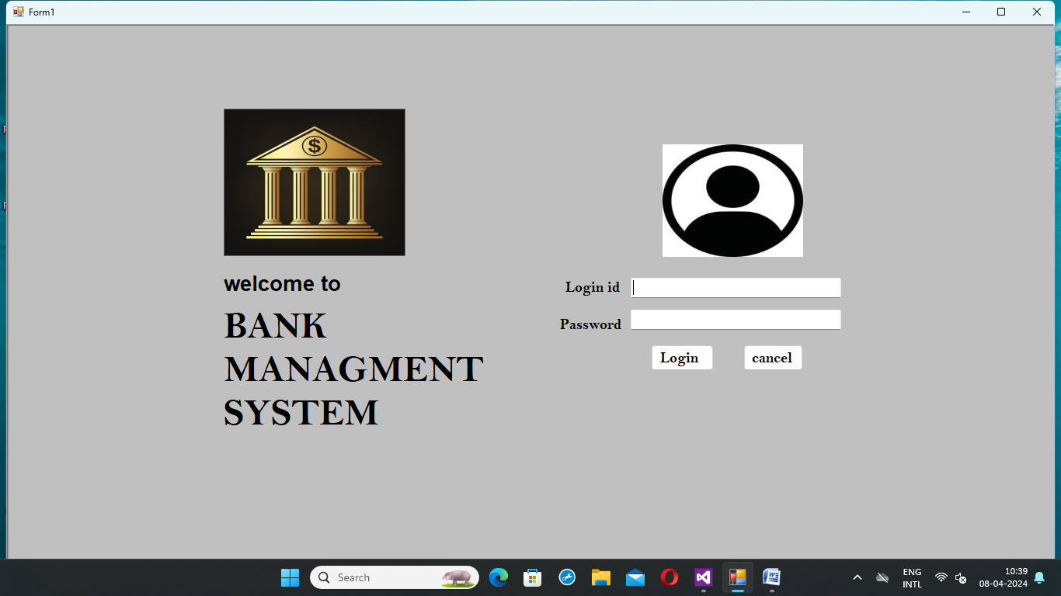

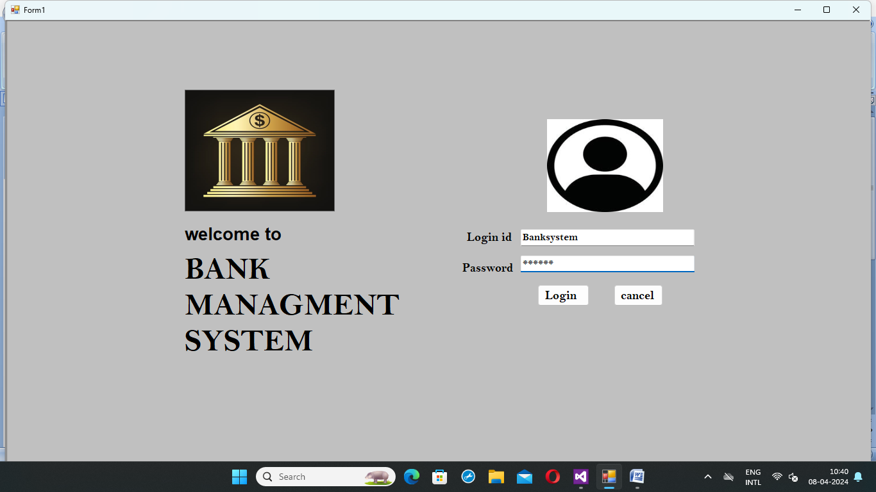

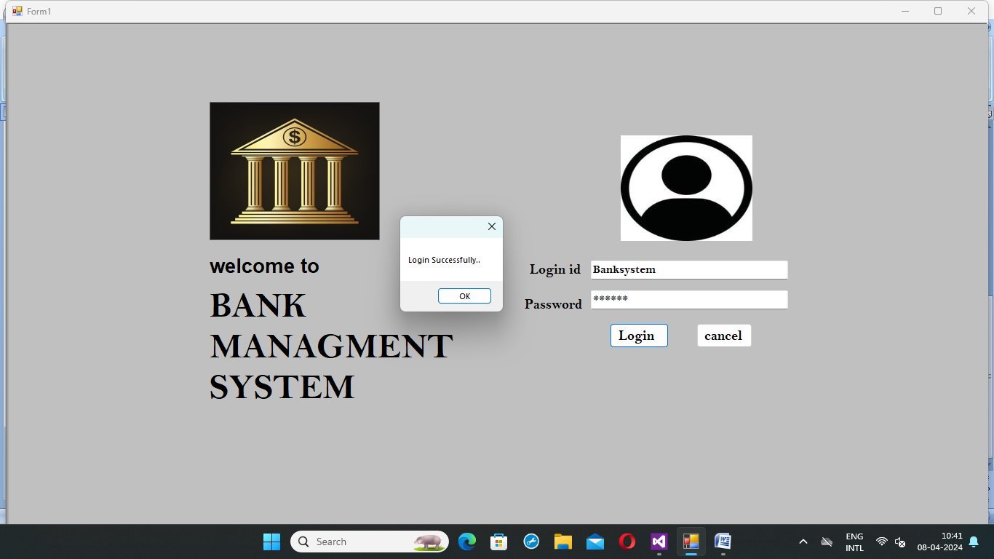

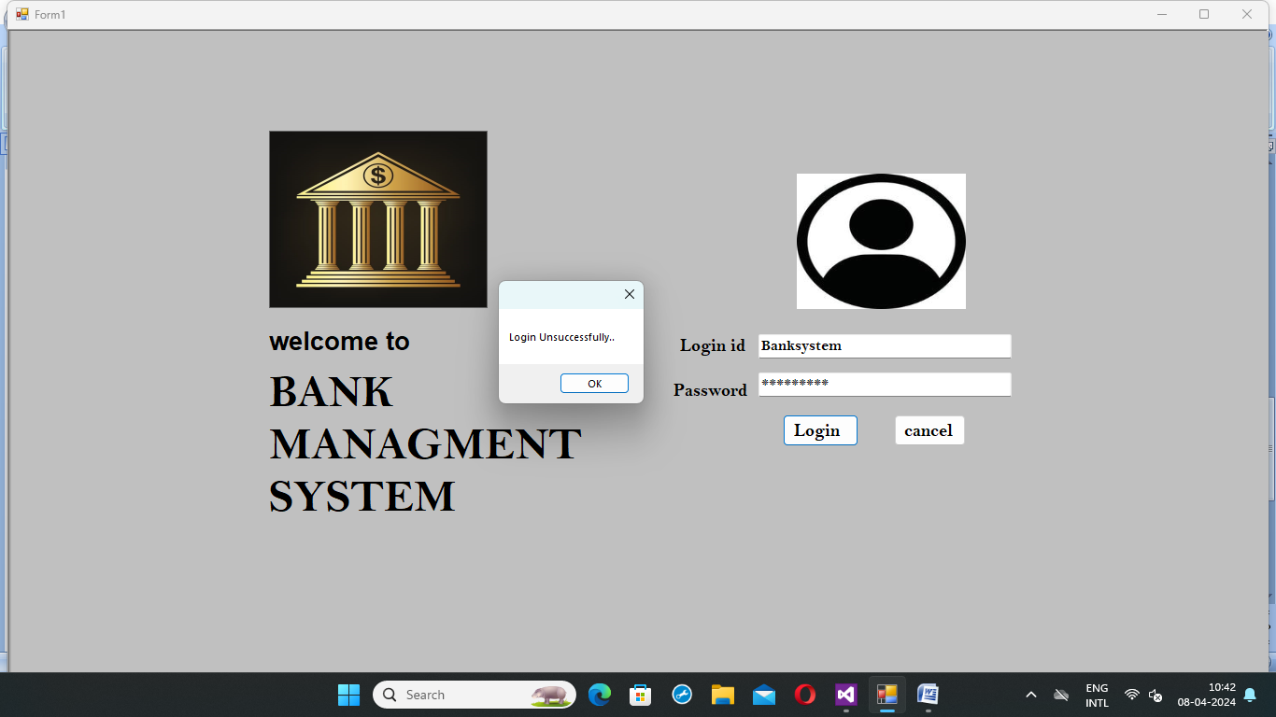

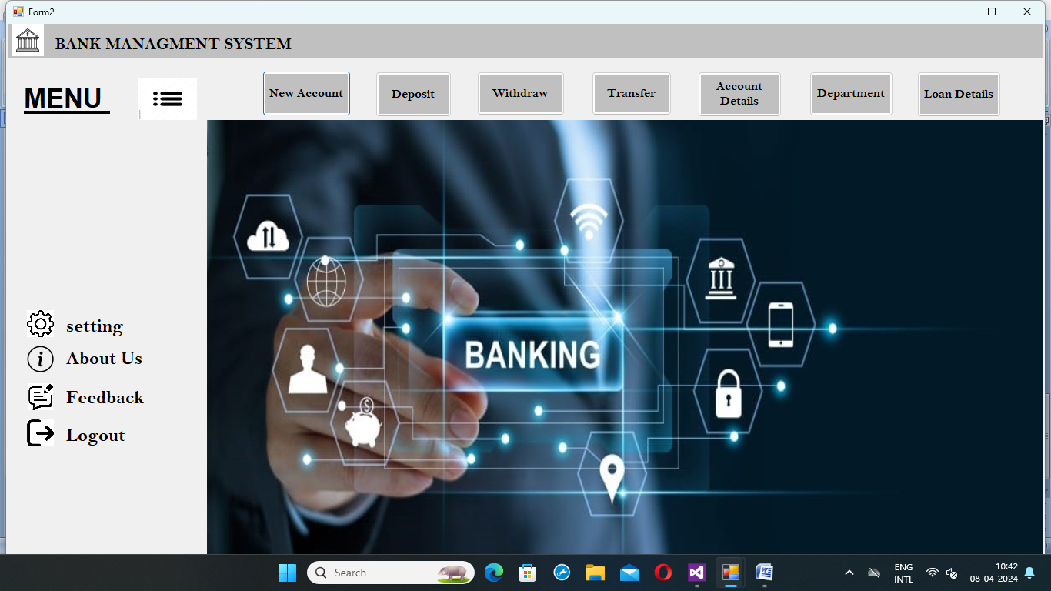

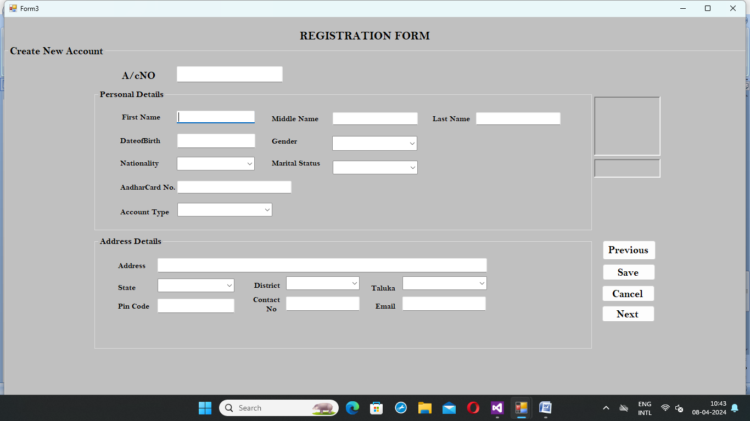

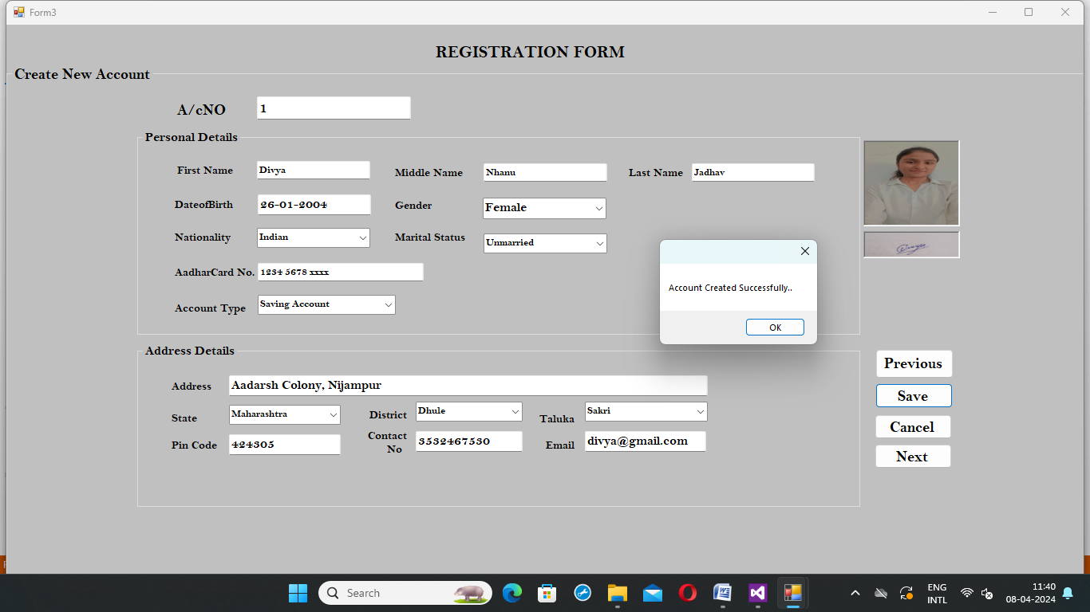

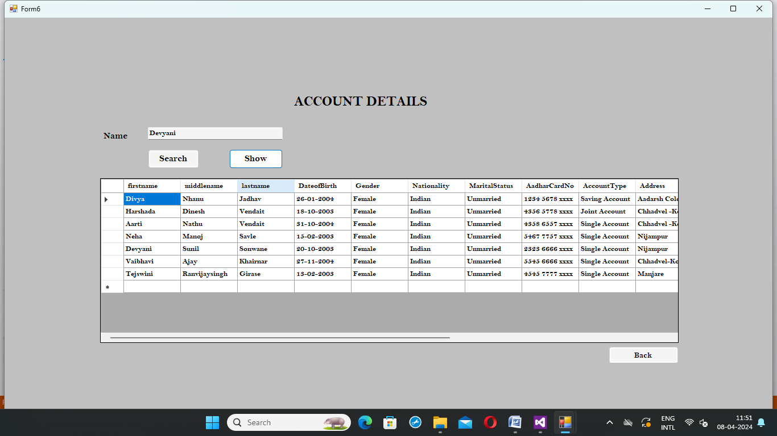

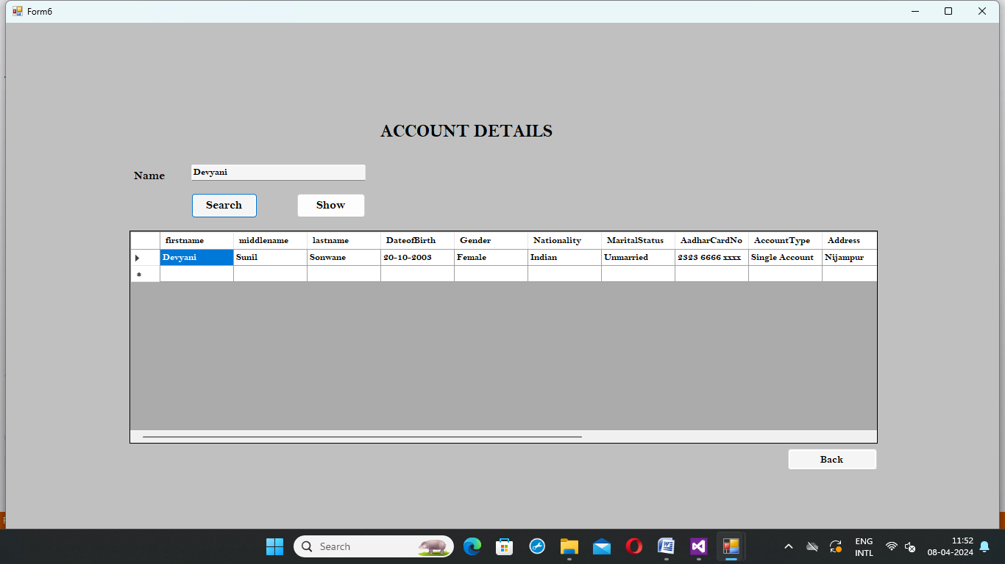

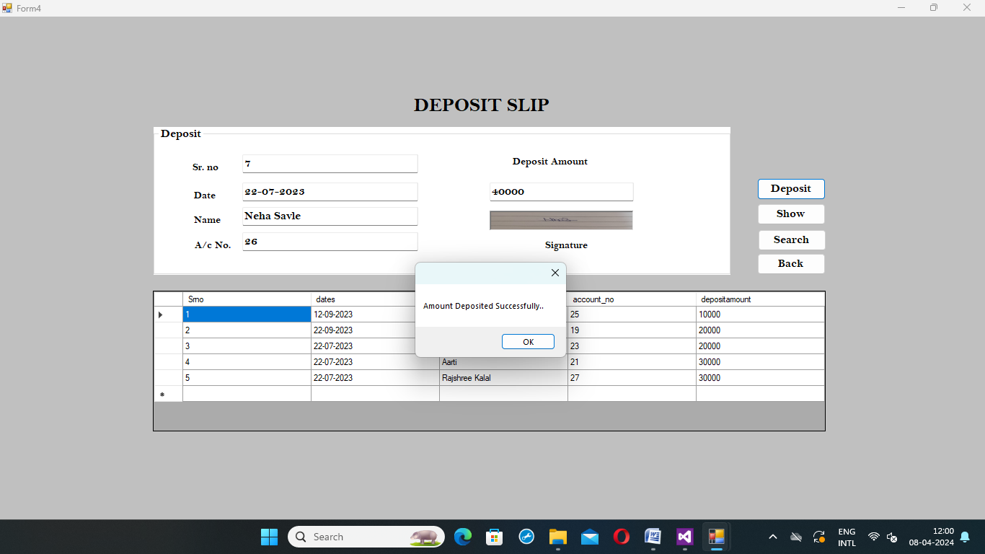

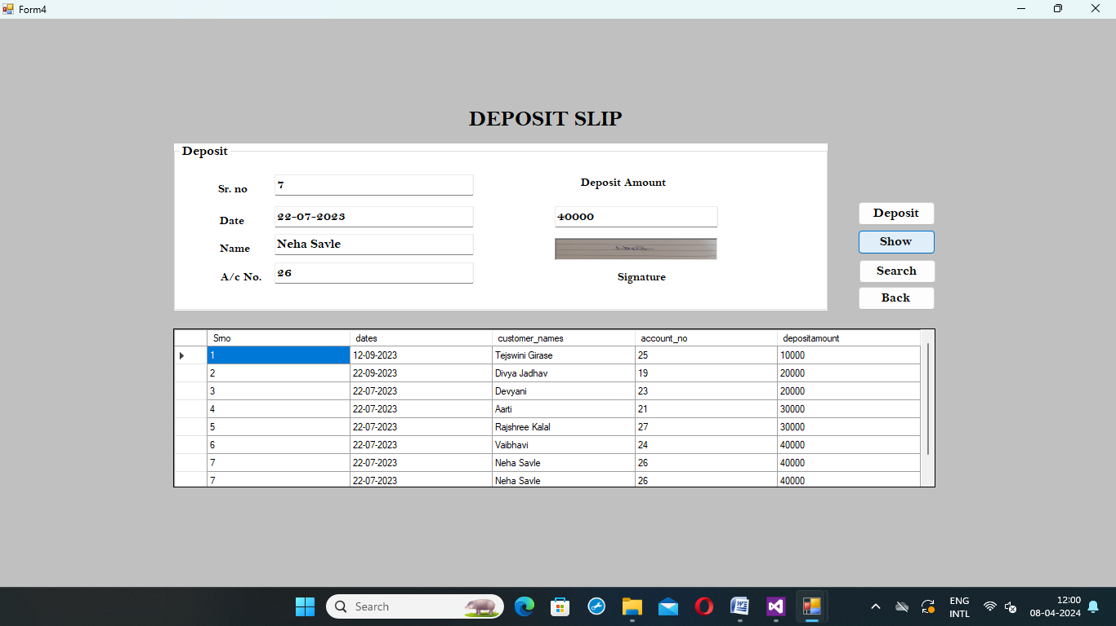

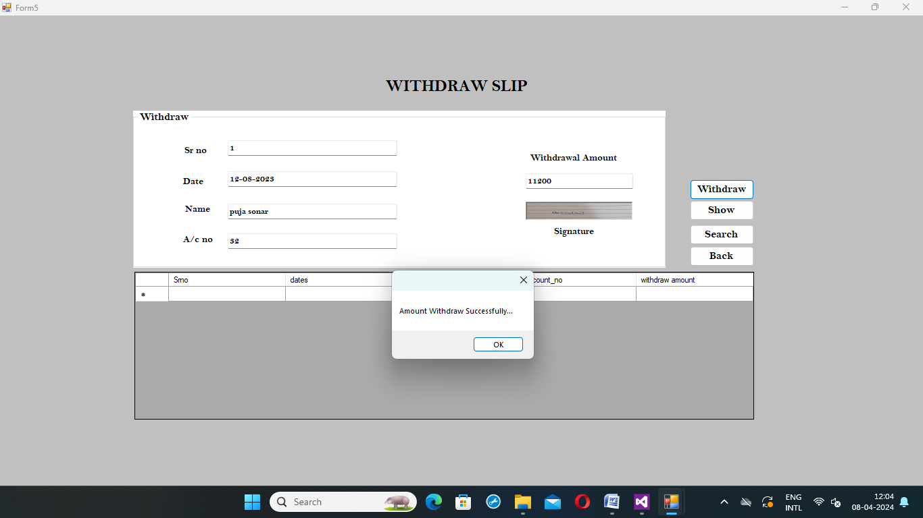

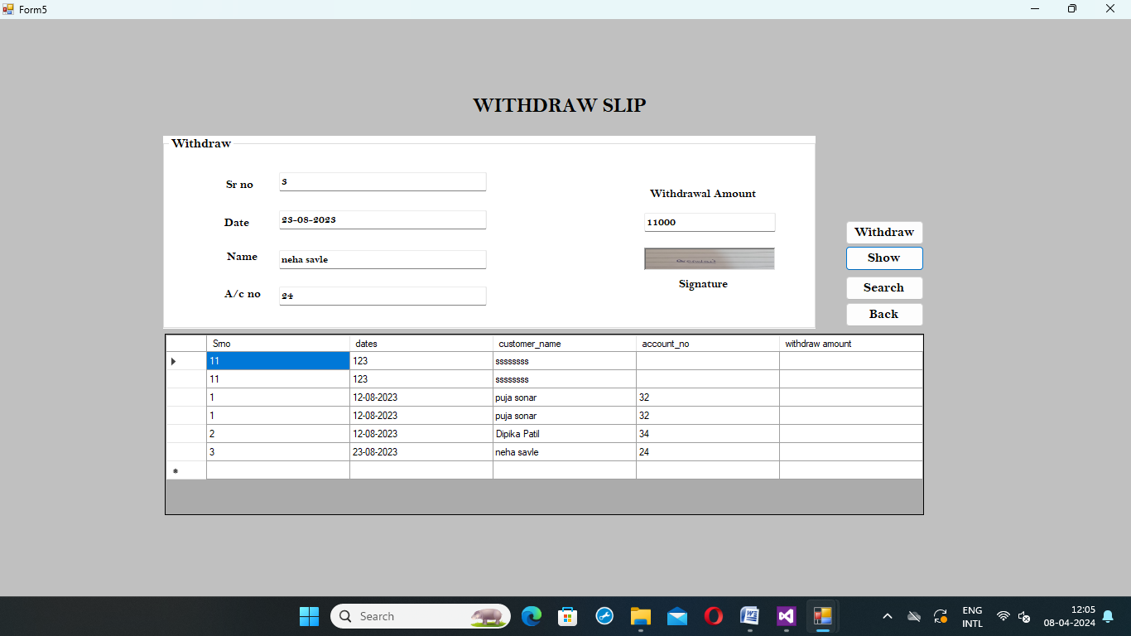

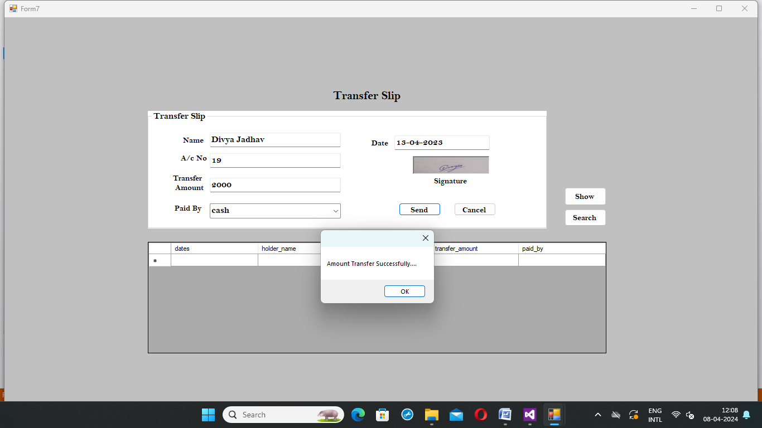

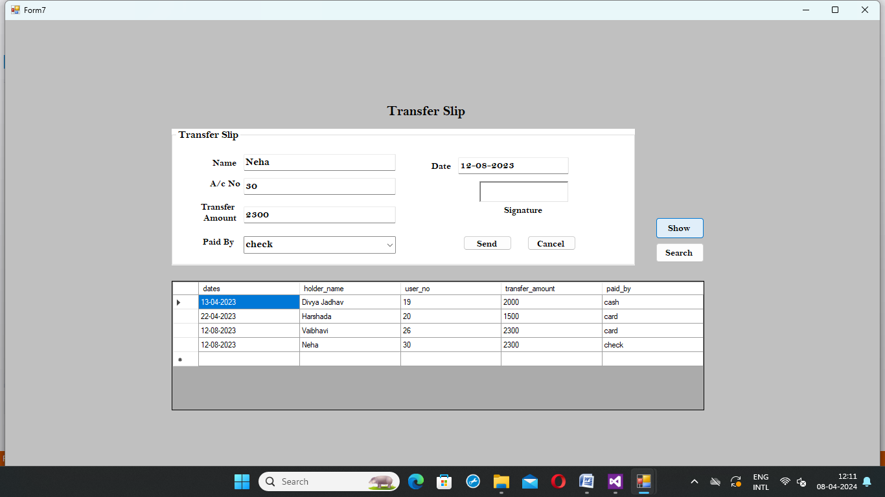

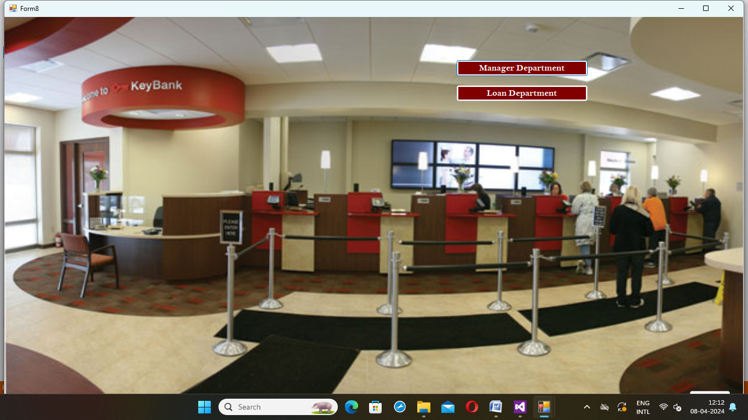

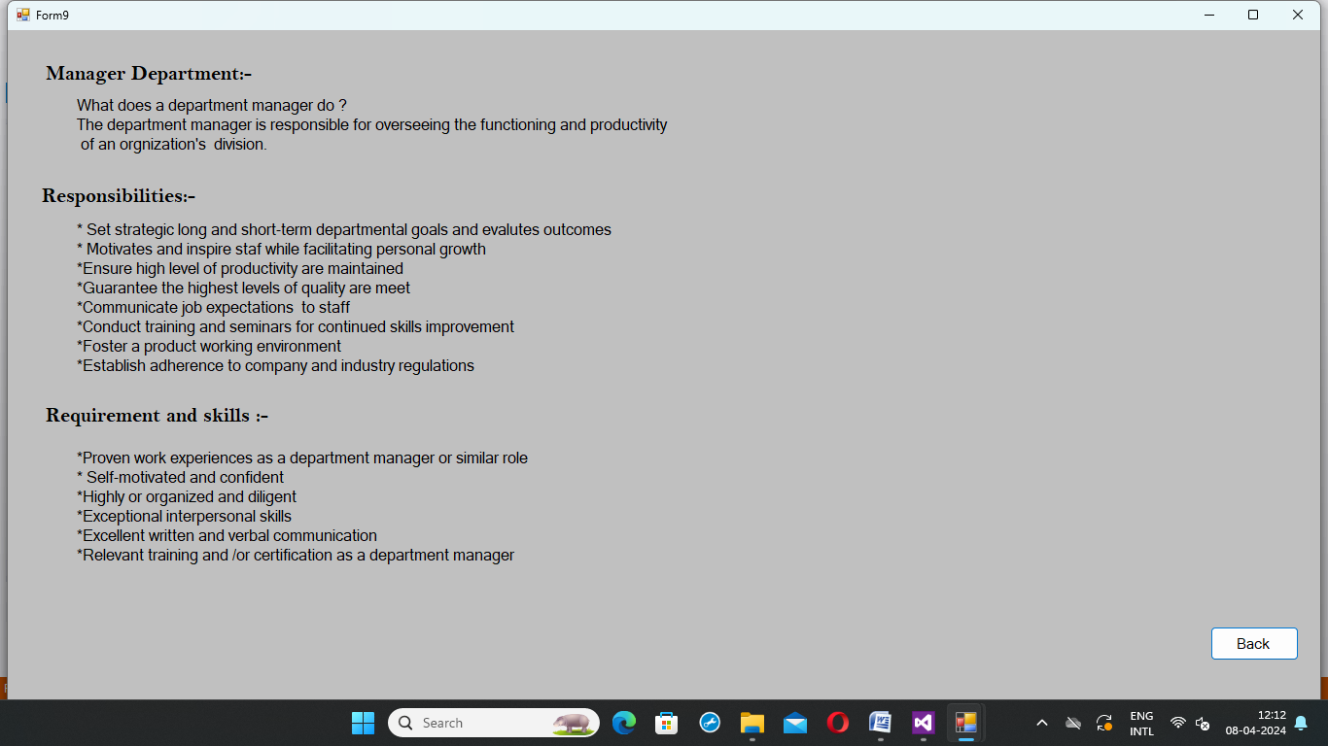

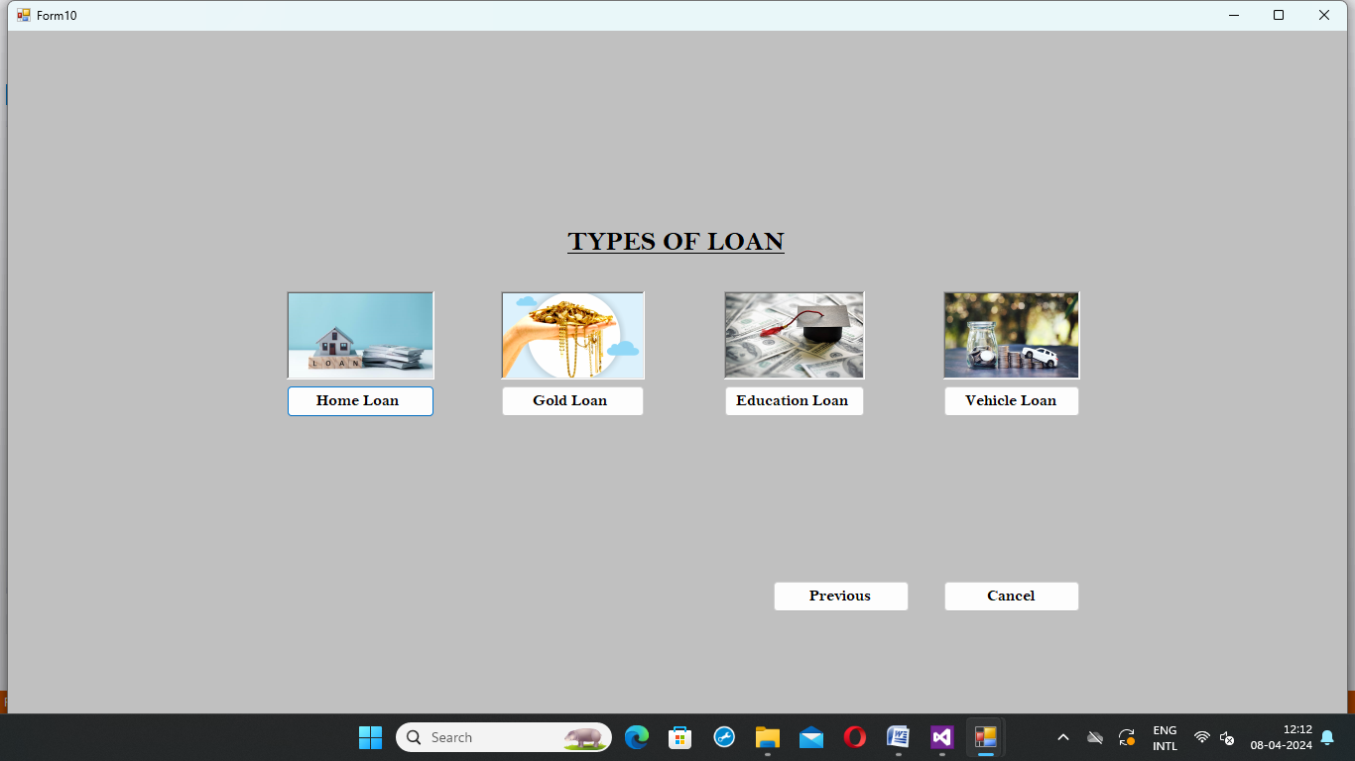

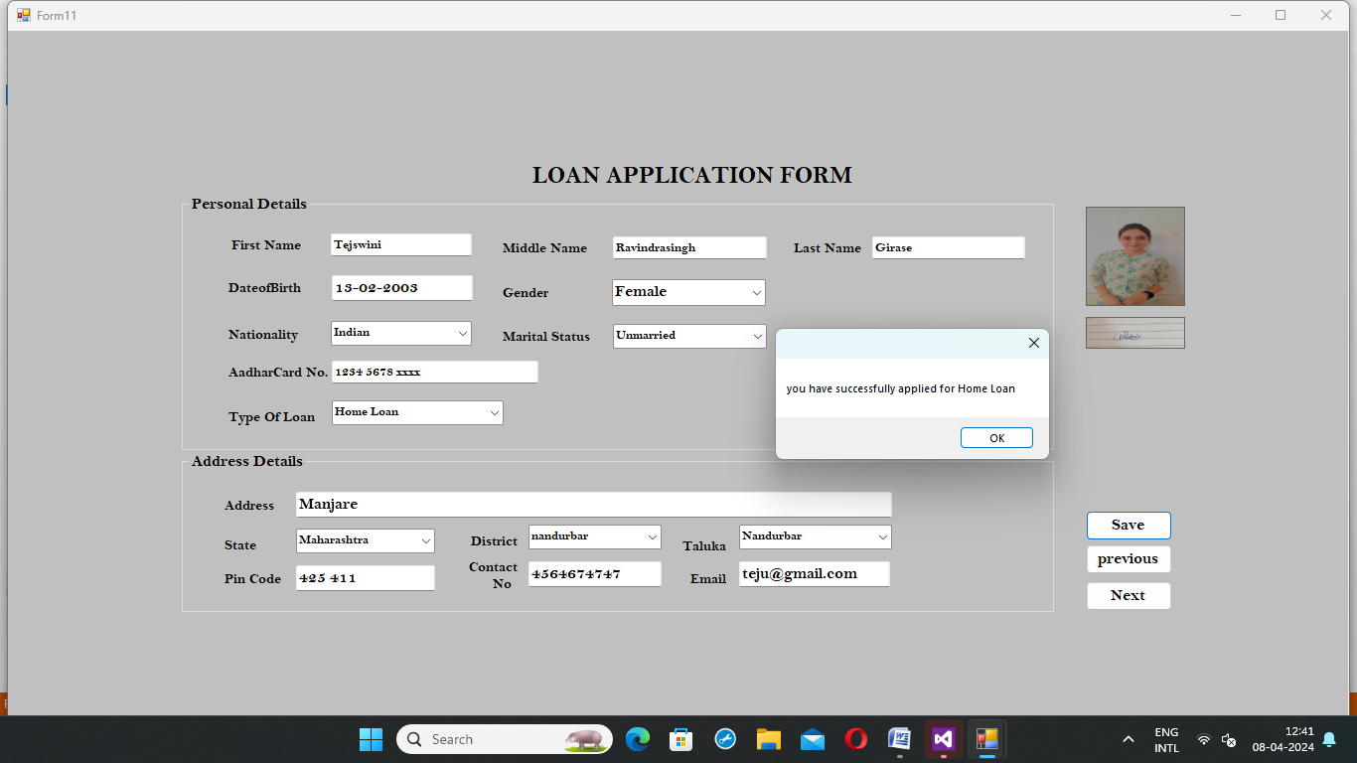

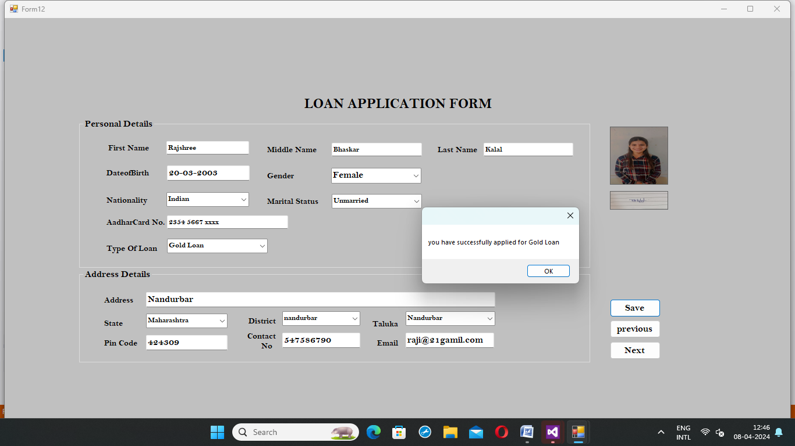

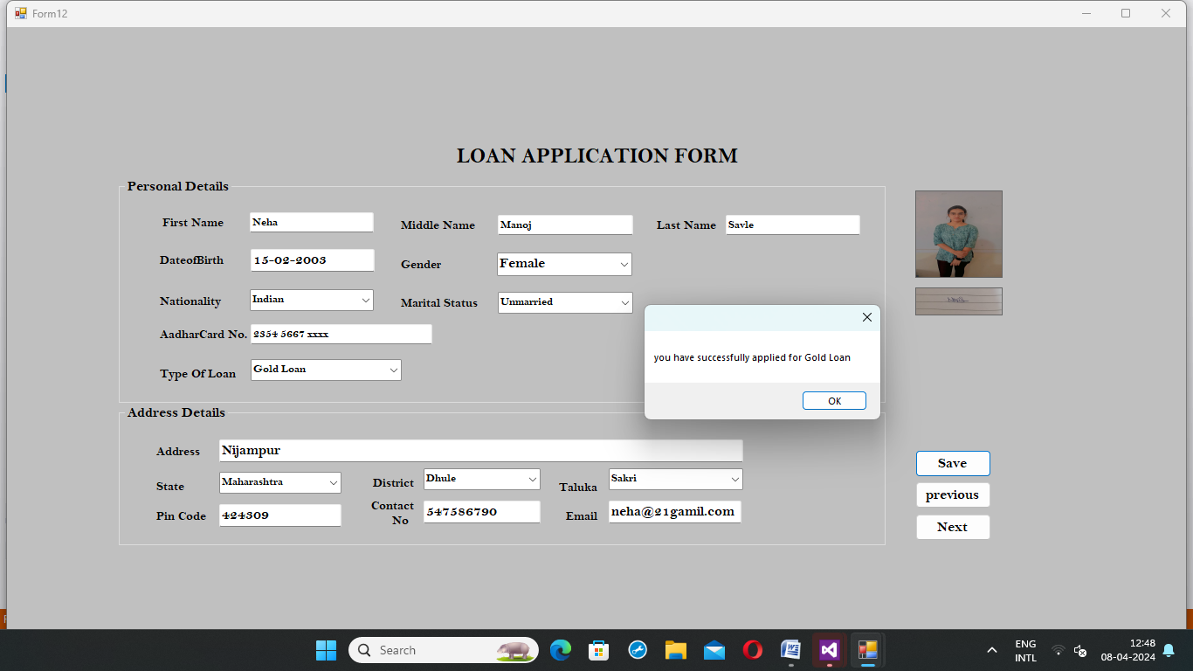

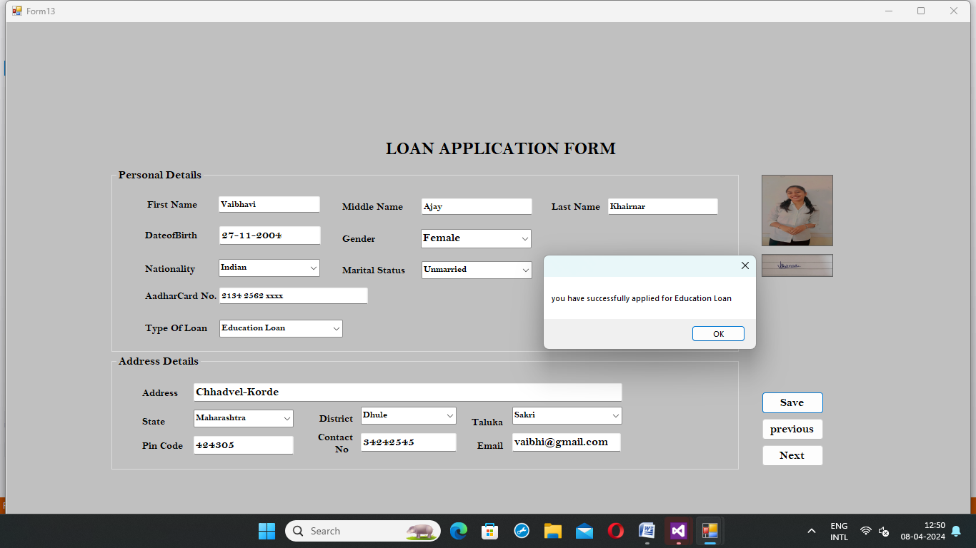

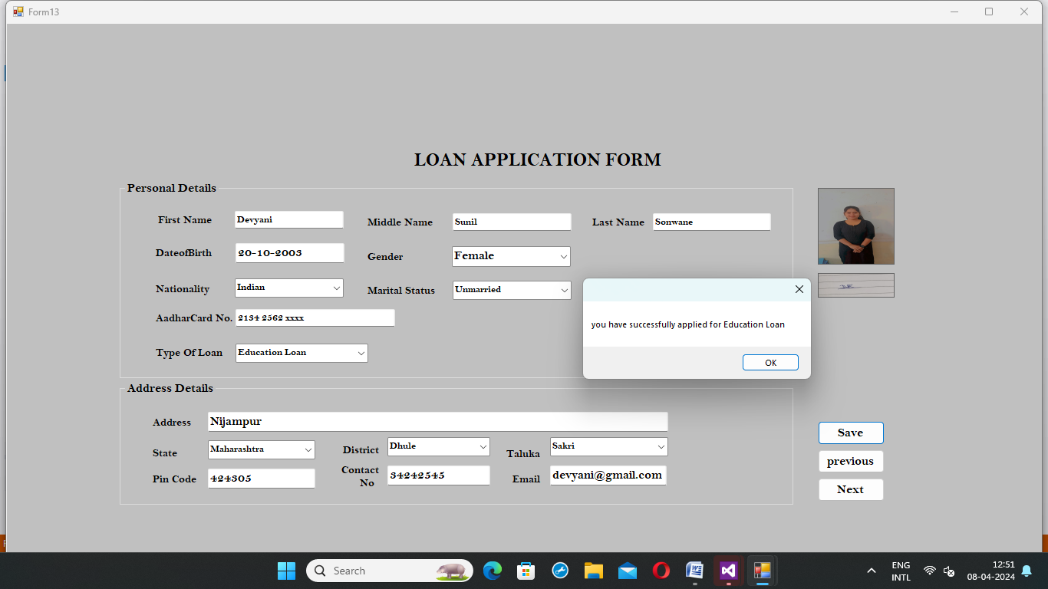

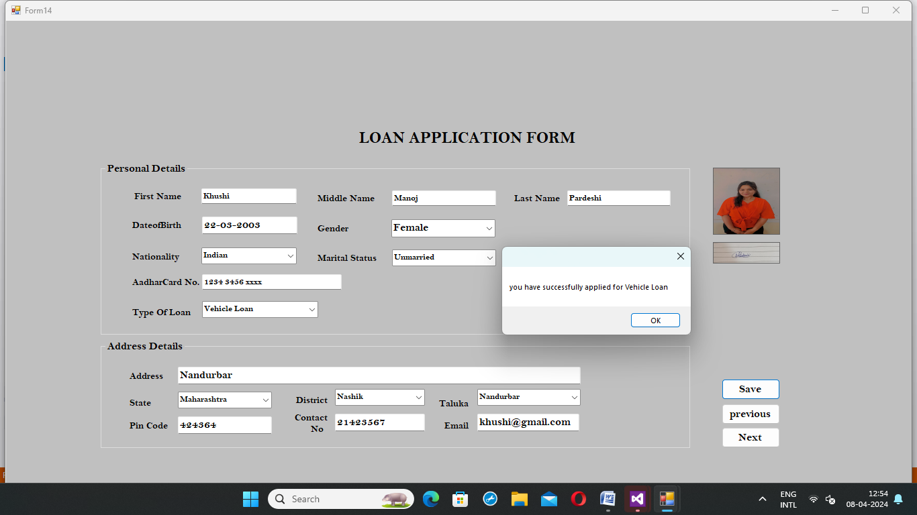

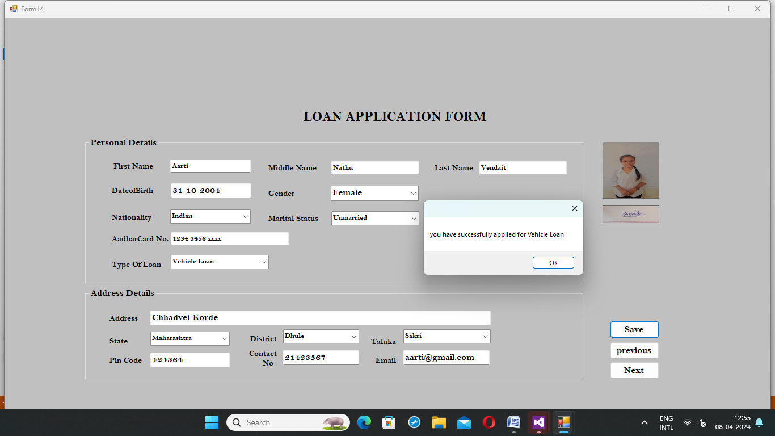

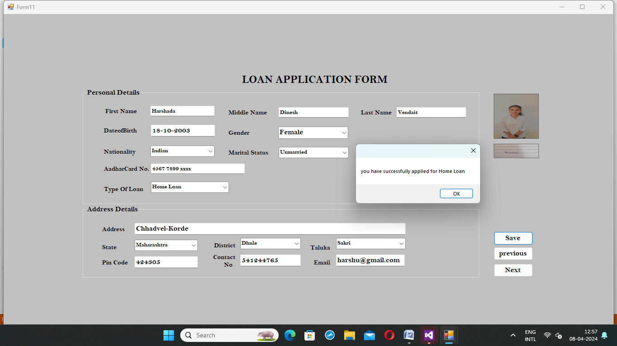

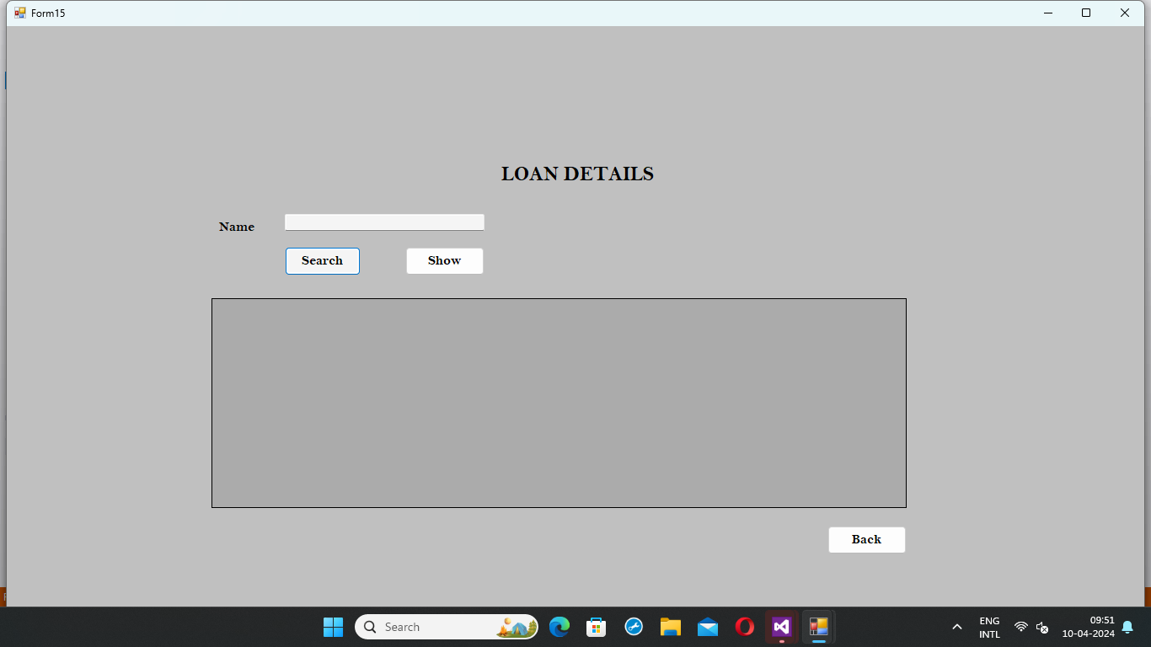

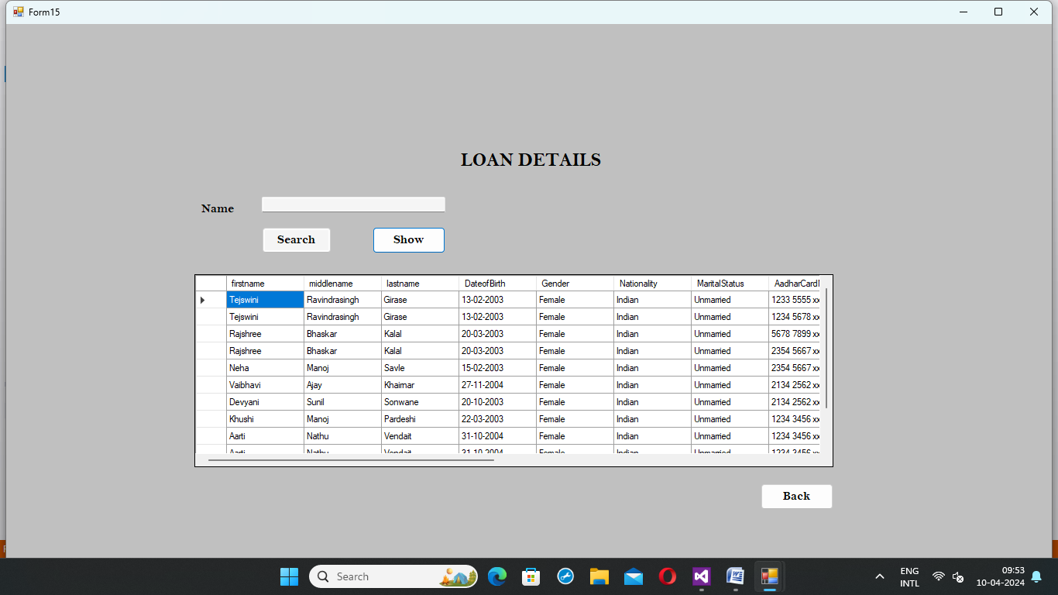

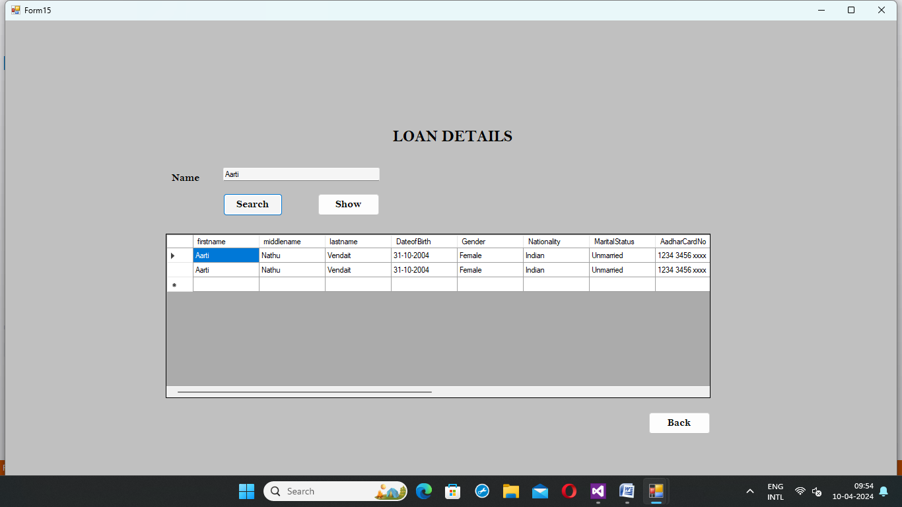

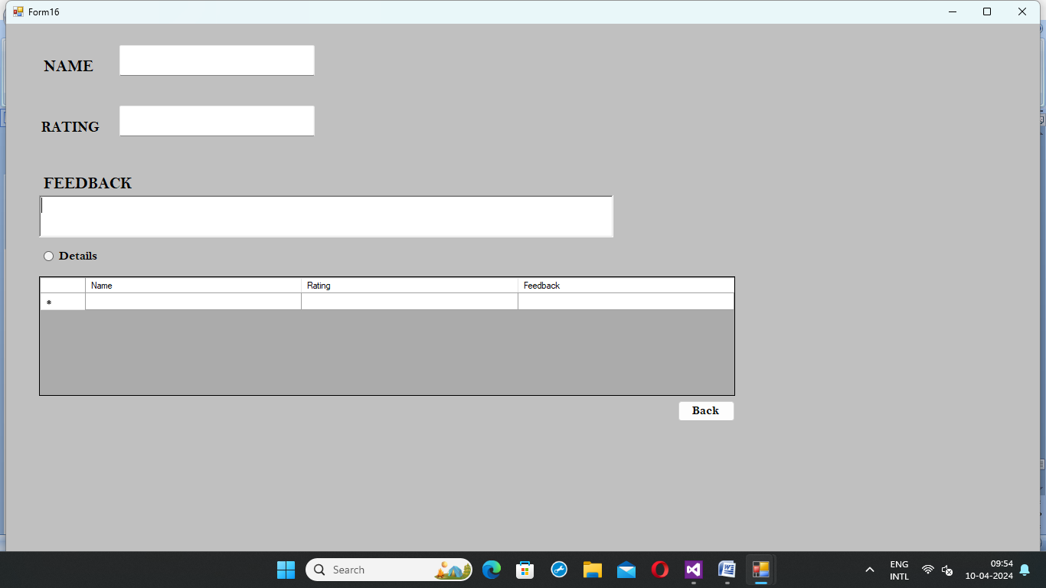

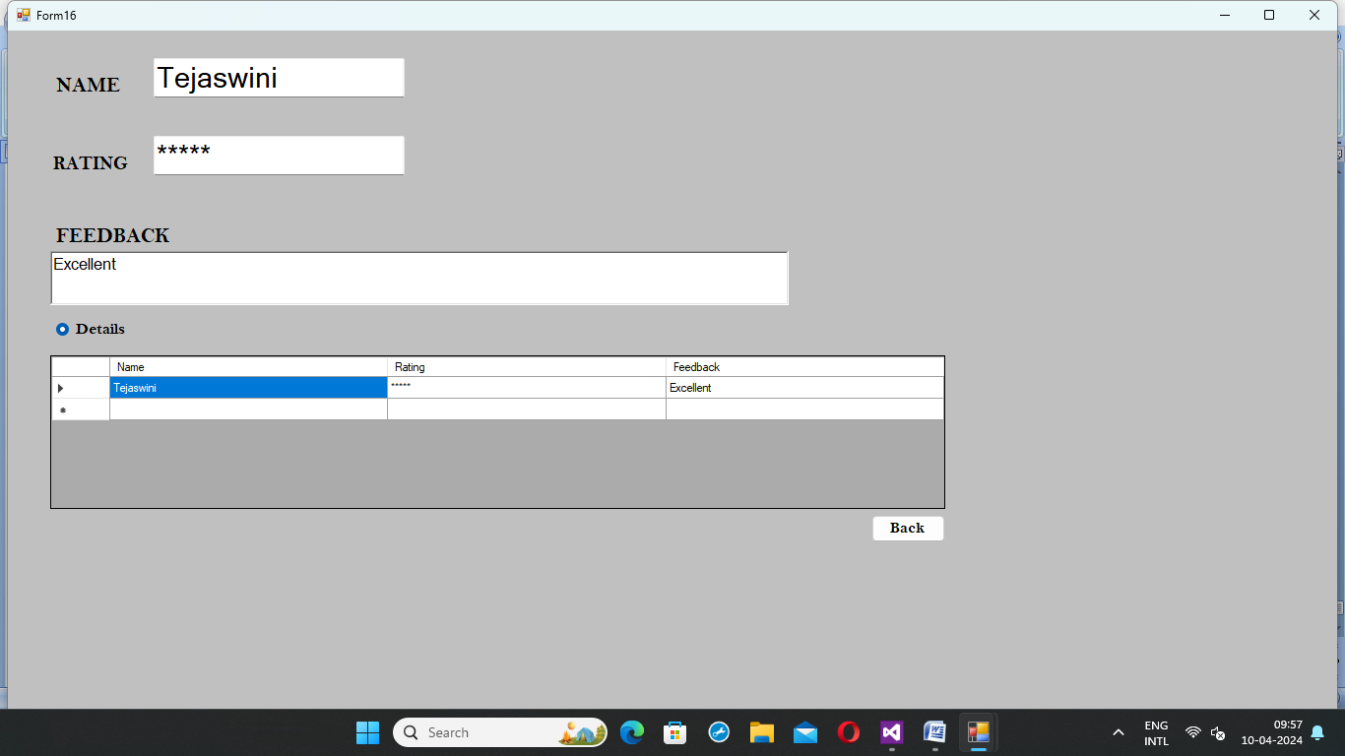

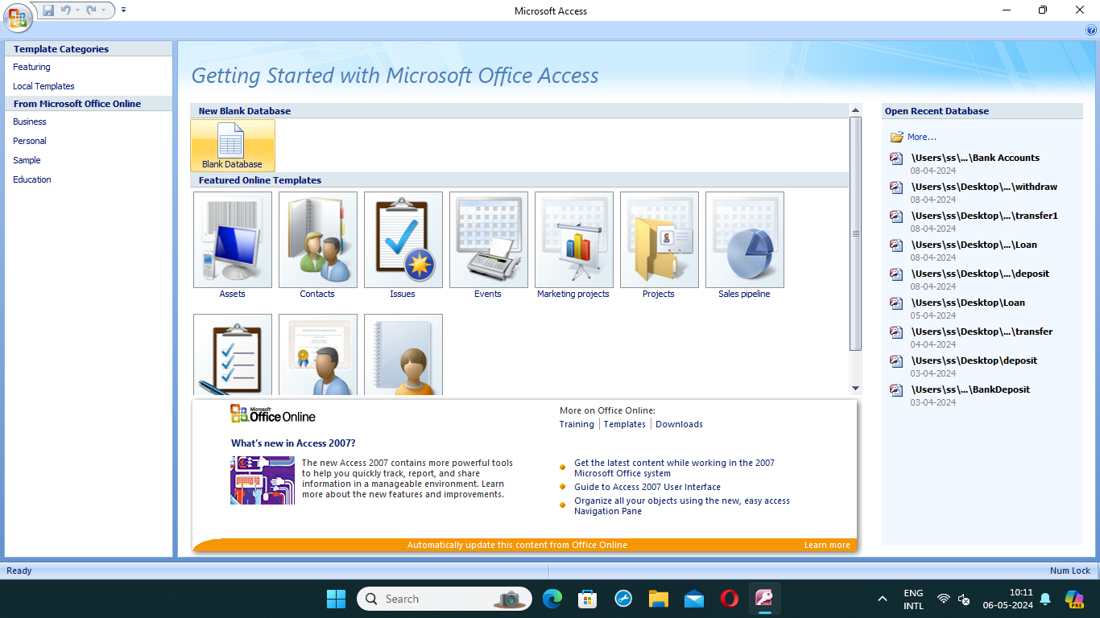

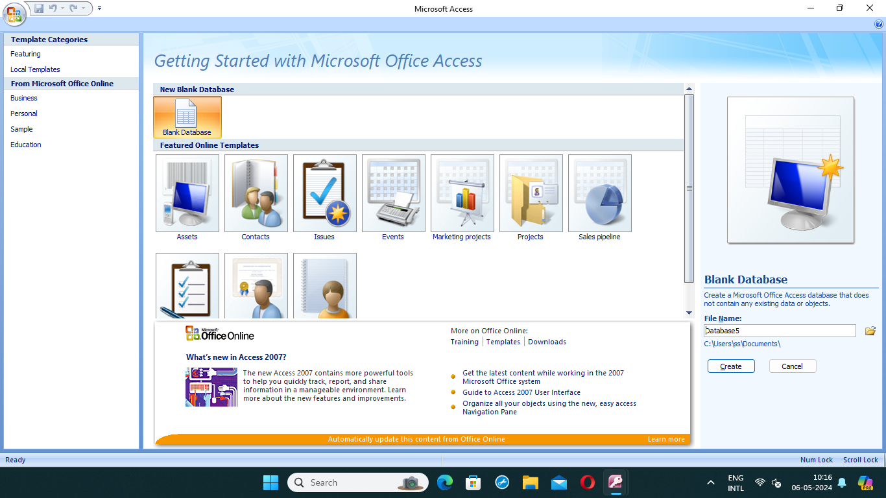

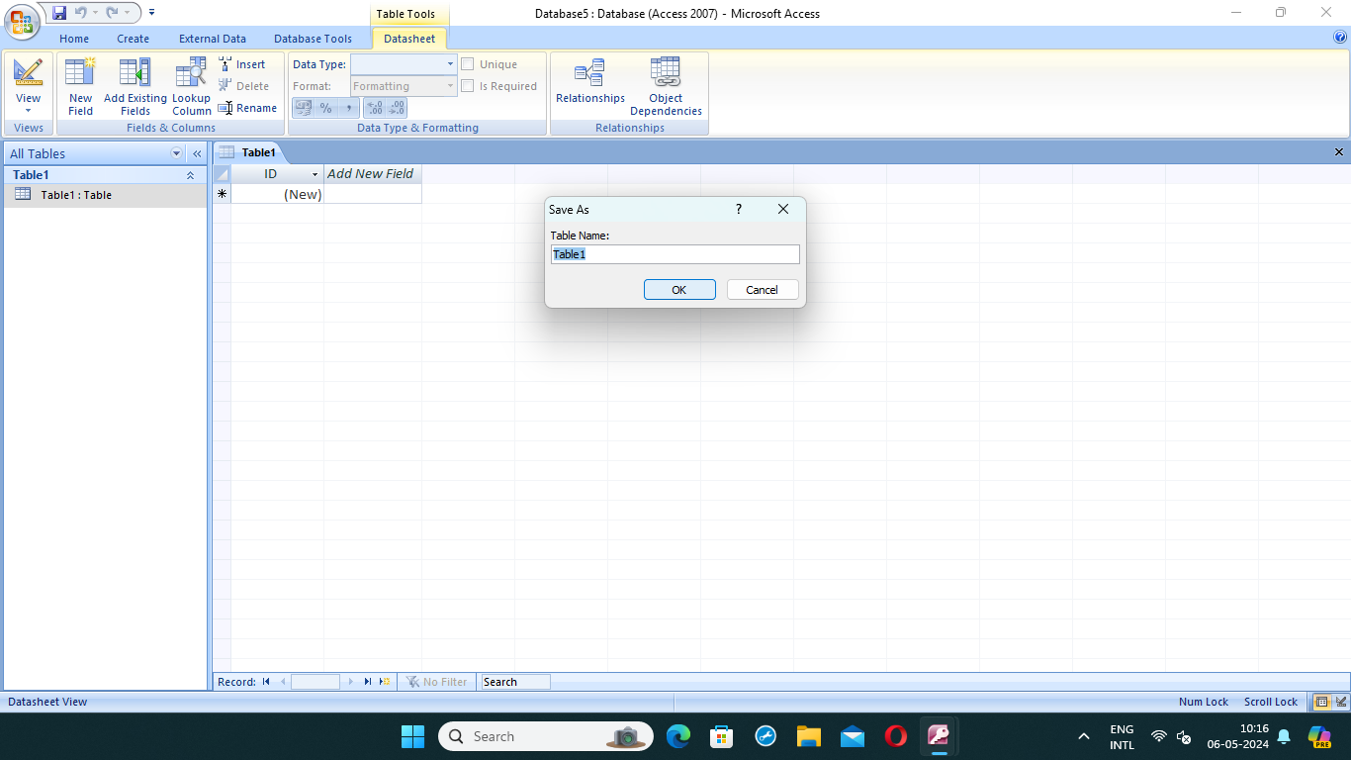

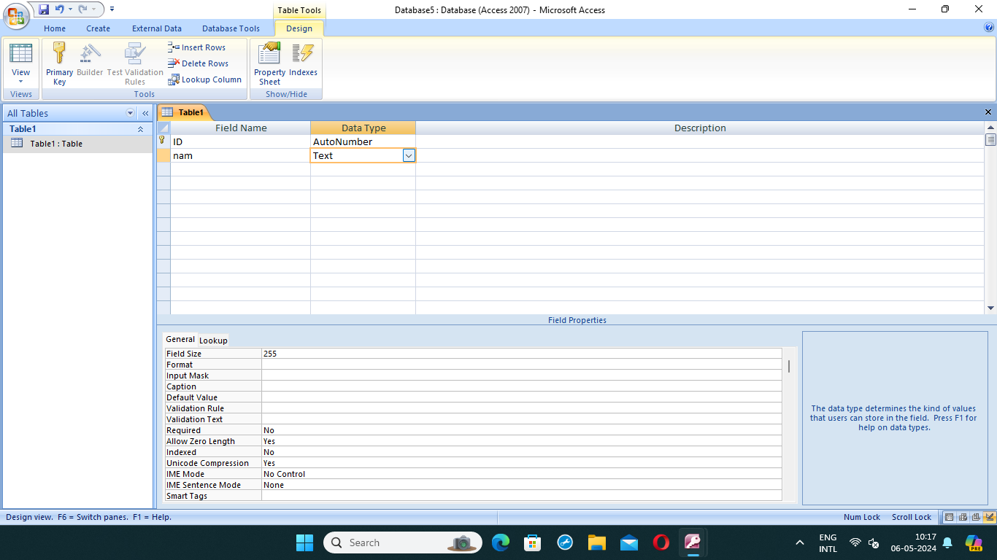

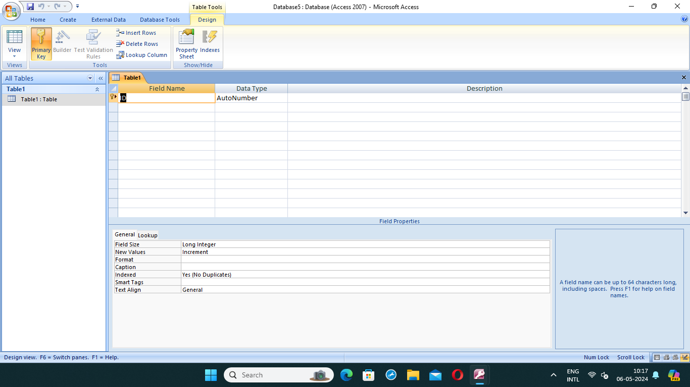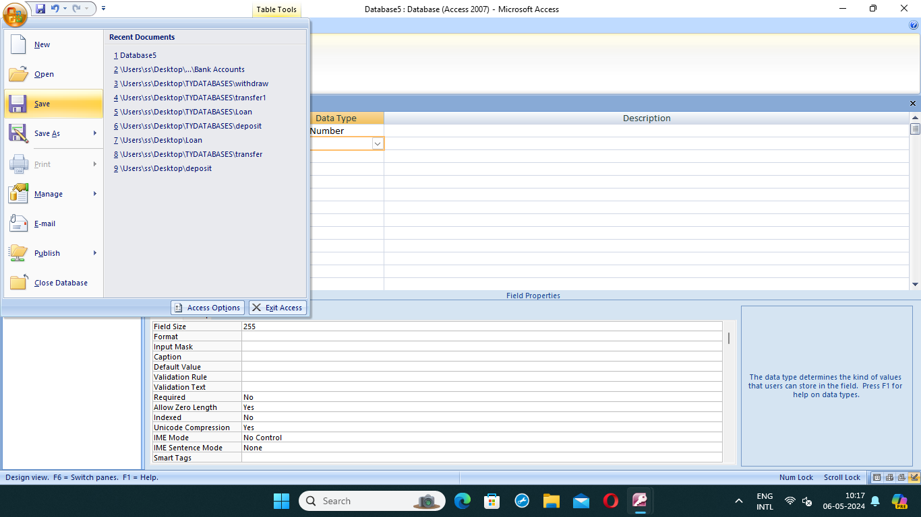

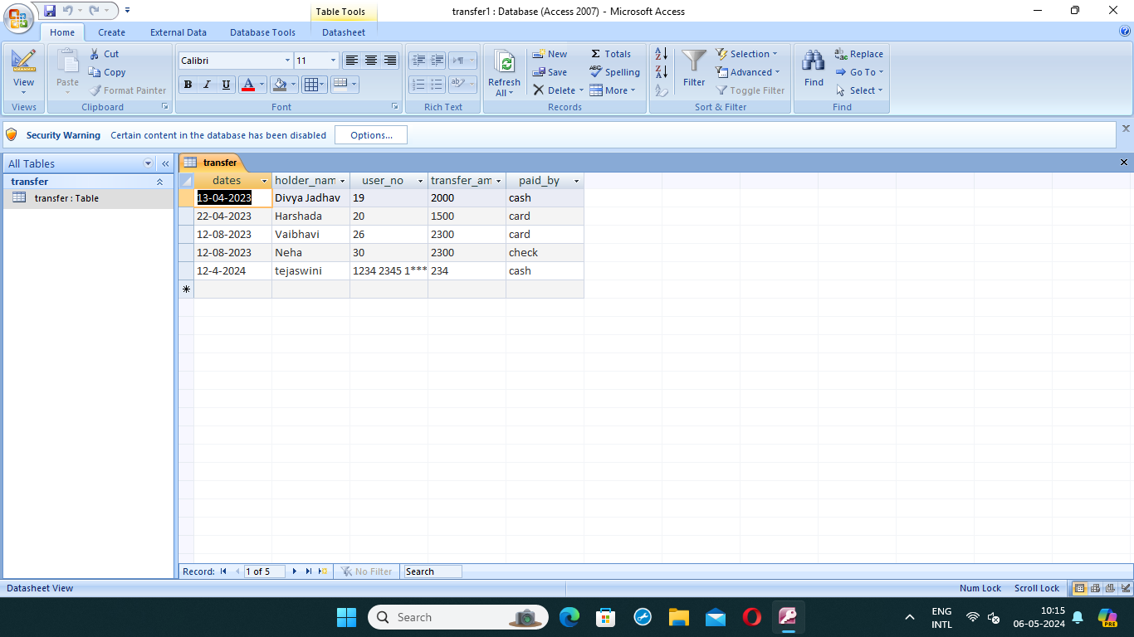

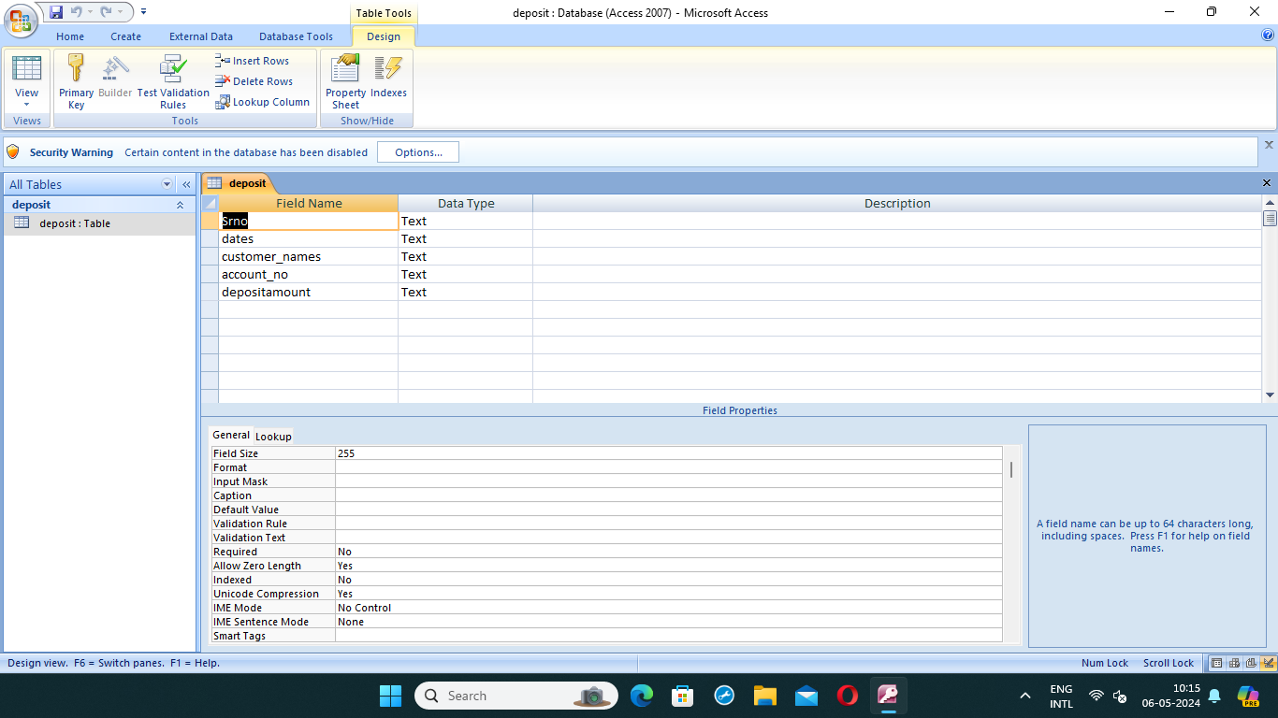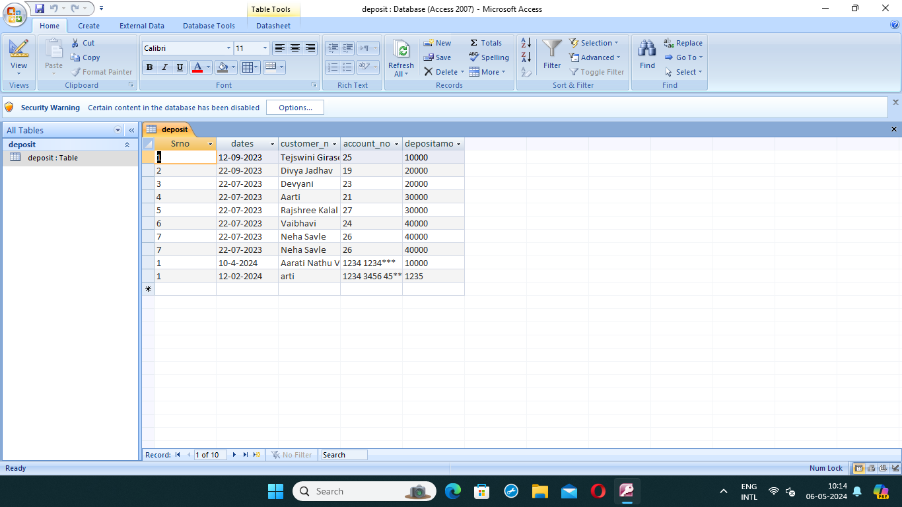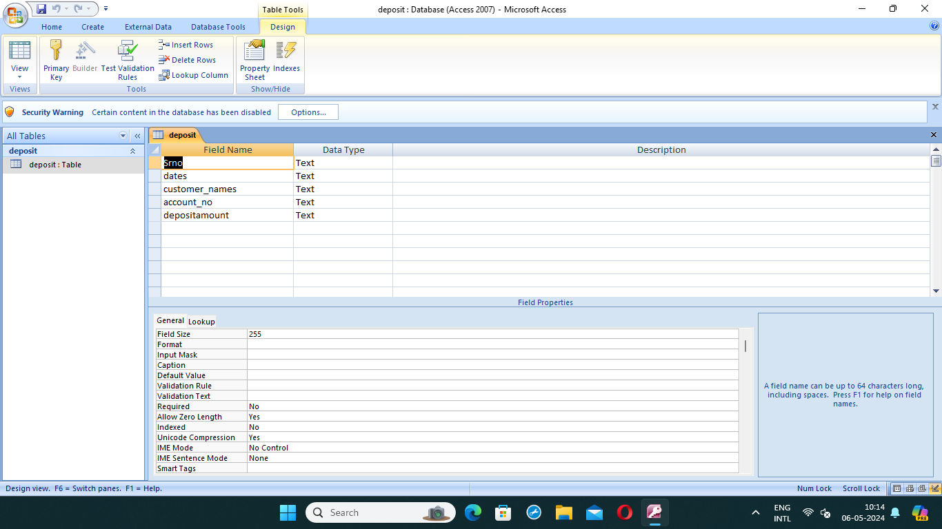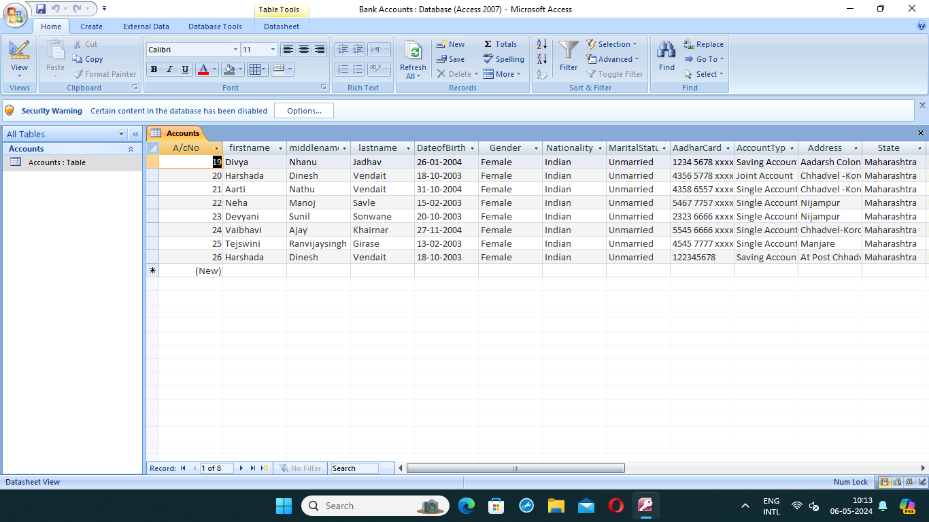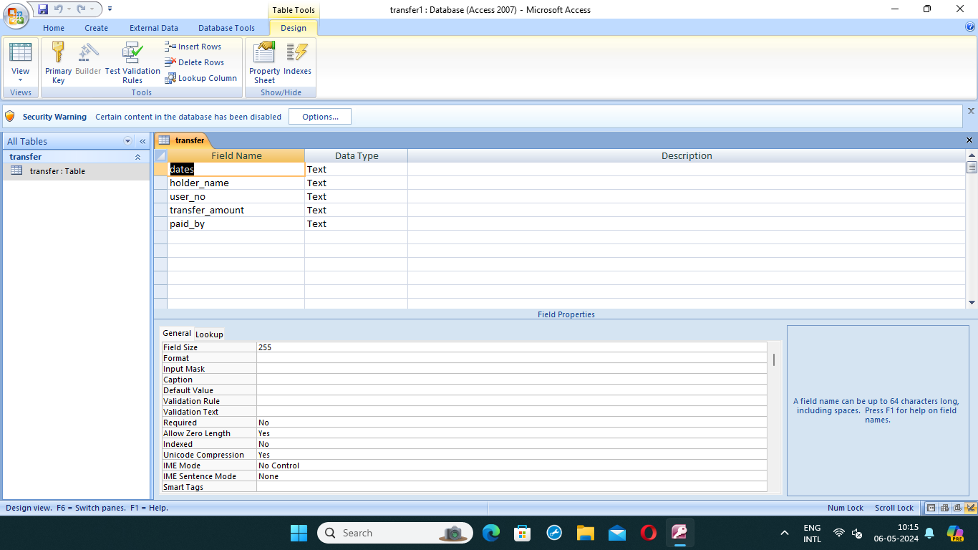

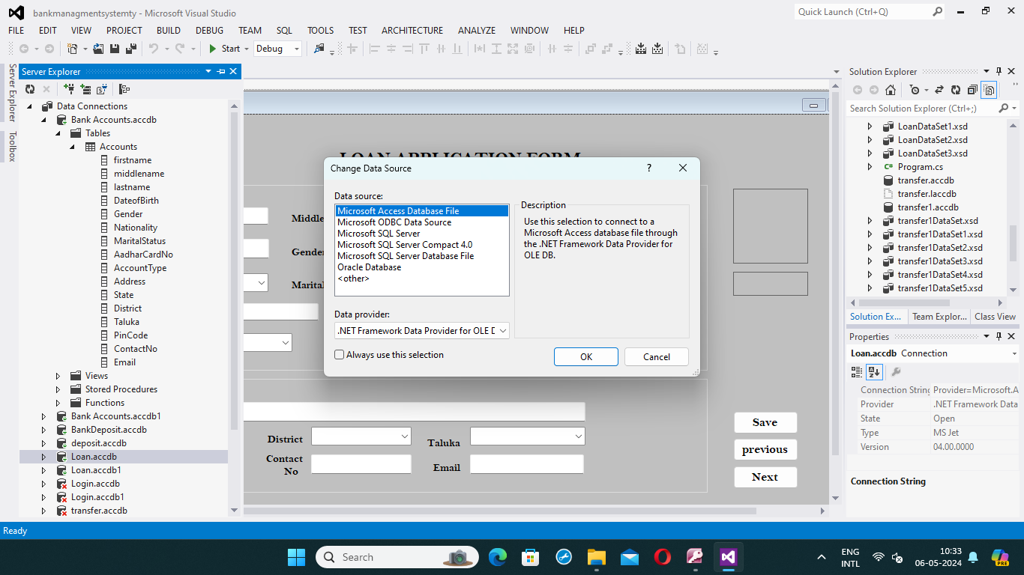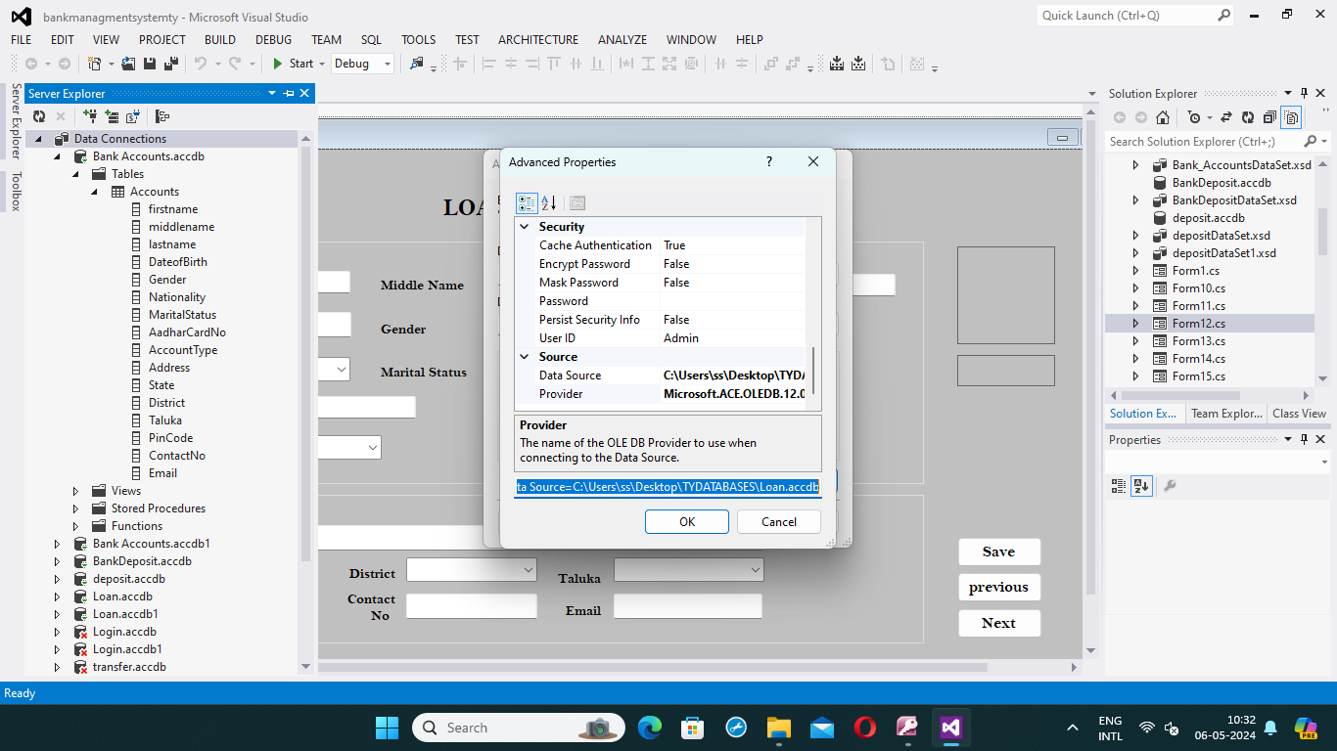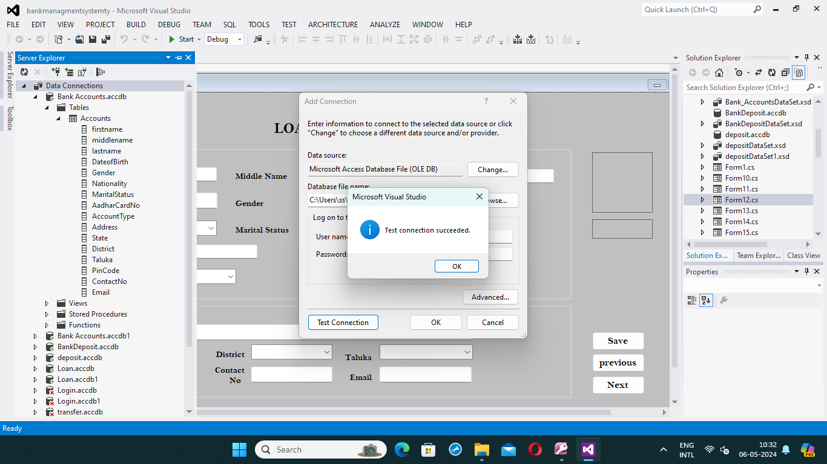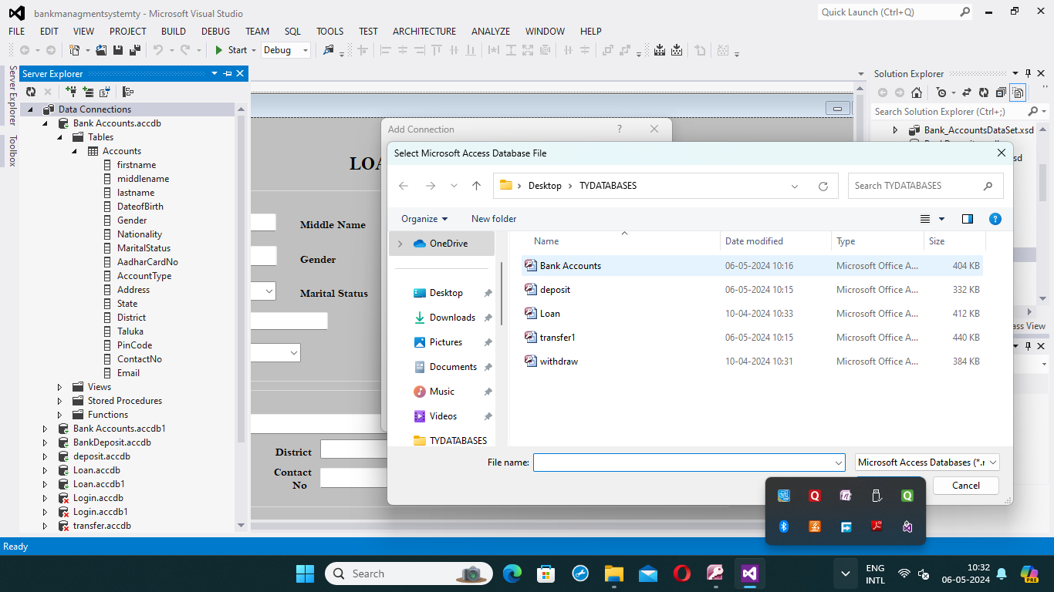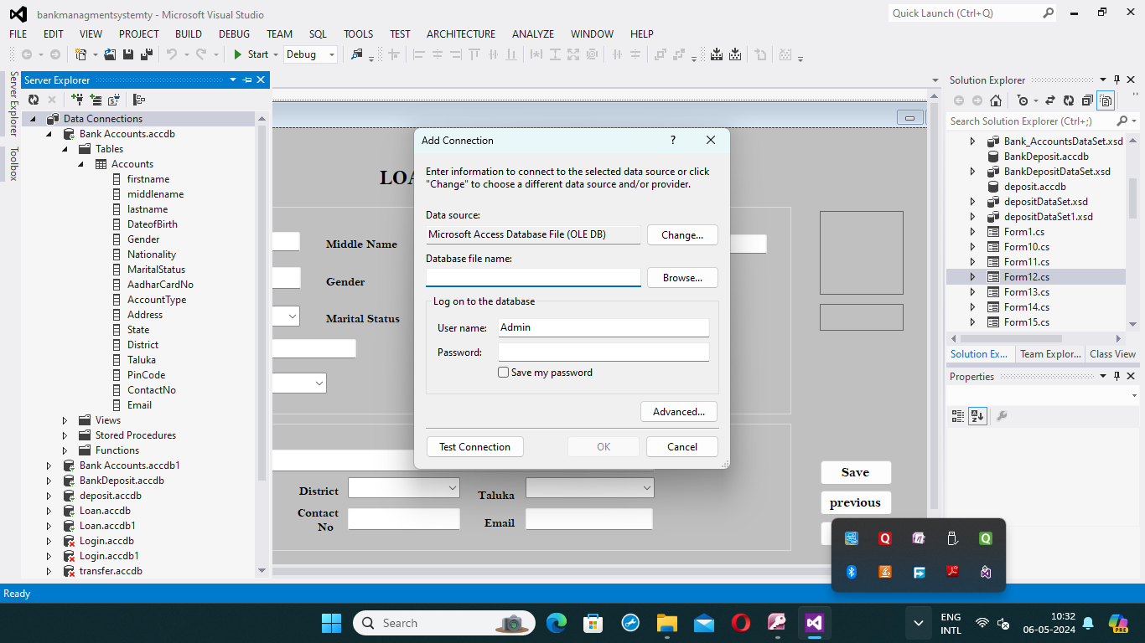

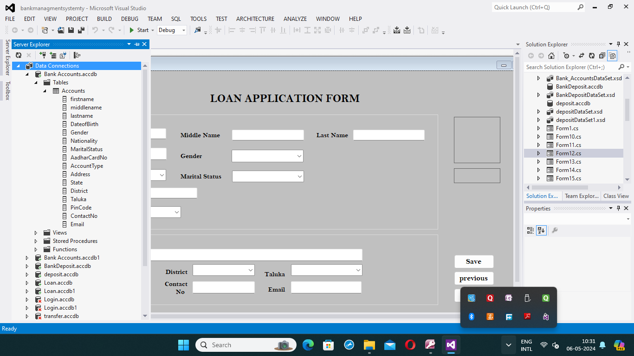

**Thank you**